Dr. Julija Sardelić
Marie Skłodowska-Curie Postdoctoral Fellow

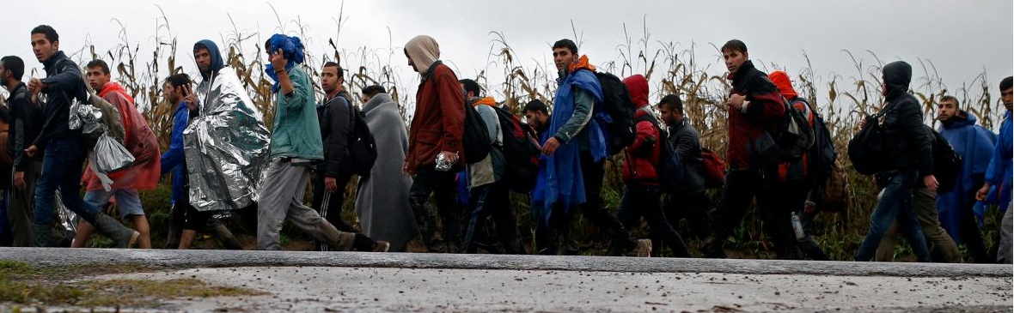

From temporary protection to transit migration:
Responses to refugee crises in the Balkans

Countries in the Western Balkans have faced several refugee crises. In the 1990s, refugee crises resulted from the disintegration of Yugoslavia. Between the summer of 2015 and early 2016, the European continent faced another refugee crisis due to the ongoing civil war in Syria. During the 2015/16 refugee crisis, different political leaders in the post-Yugoslav space claimed that their humanitarian approach towards refugees was based on their previous experience from the 1990s. This paper explores and compares legal and political responses of five countries along the Western Balkan route: three European Union Member States (Austria, Slovenia and Croatia) and two EU candidate countries (Serbia and North Macedonia). The Temporary Protection Directive, an EU law developed during the Yugoslav refugee crisis has faced ambivalent application during the 2015/16 refugee crisis. National legislation has also changed: the main approach adopted during the Yugoslav crisis emphasized temporary protection, while in 2015/2016 the main approach concerns ‘transit migration.’

13 Sept. 2018 / 12:00 pm / Wood Room (OK 406)
Victoria University, Wellington

This event is free and open to the public



