CH3.5 91391 “Cheat sheet” for learning reactions
Print pages back to back, cut out the cards and shuffle them. You can use the cards in a number of ways.
Flash card / recall
Pick up a card, with black print facing towards you. Name as many reactions that involve that card as a reactant, reagent or product. Then turn over the card to see if you are correct.
Game challenge
Share out the cards amongst players. See how many reactions you can make or how many cards you can use up. The one who can make the most reactions / uses the most cards wins. (If playing by yourself, then draw 15 cards)
Reaction scheme :
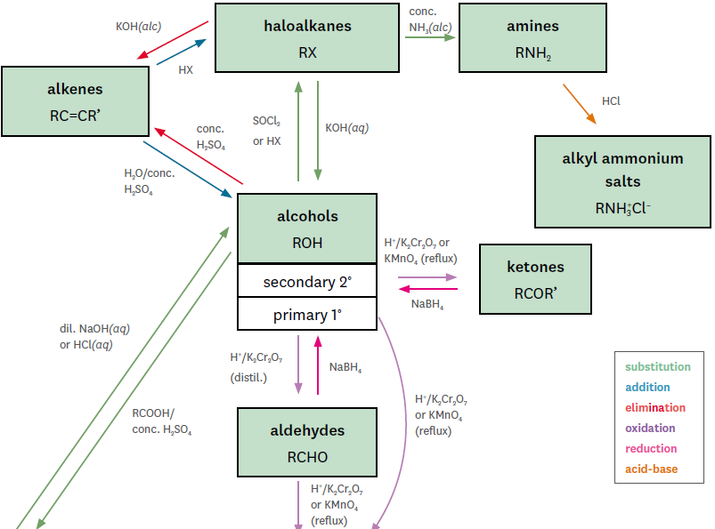
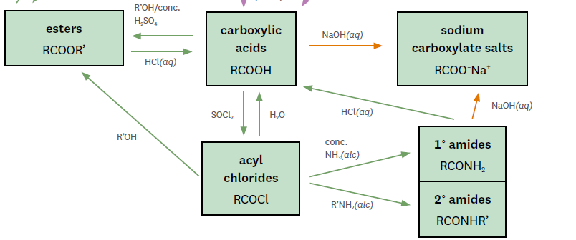

RC=CR’ | RC=CH₂ | 1º  R–X
2º  R–X | 1º  R–OH | 2º  R–OH
R–NH₂ | R’  ӏ  R – NH |   R–C–H

OH⁻(alc)  1º R–X → RC=CH₂  Conc NH₃  1º R–X → RNH₂  R’–NH₂  1º R–X → RNH–R’  OH⁻(aq)  1º R–X → 1º R–OH  SOCl₂  1º R–OH → 1º R–X  HX  RC=CH₂ → 1º R–X | H₂/Pt  RC=CH₂ → RCH₂–CH₃  HX  RC=CH₂ → 1º R–X (minor)  Conc H₂SO₄/H₂O  RC=CH₂ → 1º R–OH (minor)  Conc H₂SO₄/H₂O  RC=CH₂ → 2º R–OH (major)  Conc H₂SO₄  1º R–OH → RC=CH₂  OH⁻(alc)  1º R–X → RC=CH₂ | H₂/Pt  RC=CR’ → RCH–CHR’  HX  RC=CR’ → 2º R–X  Conc H₂SO₄/H₂O  RC=CR’ → 2º R–OH  Conc H₂SO₄  2º R–OH → RC=CR’  OH⁻(alc)  2º R–X → RC=CR’
Conc H₂SO₄  2º R–OH → RC=CR’  SOCl₂  2º R–OH → 2º R–X  R’COOH / conc H₂SO₄  2º R–OH → R’COOR  H⁺/Cr₂O₇²⁻ reflux OR H⁺/MnO₄⁻  2º R–OH → RCOR’  Conc H₂SO₄/H₂O  RC=CH₂ → 2º R–OH (major)  Conc H₂SO₄/H₂O  RC=CR → 2º R–OH (major)  OH⁻(aq)  2º R–X → 2º R–OH  NaBH₄  RCOR’ → 2º R–OH | Conc H₂SO₄  1º R–OH → RC=CH₂  SOCl₂  1º R–OH → 1º R–X  H⁺/Cr₂O₇²⁻ distil  1º R–OH → RCHO  R’COOH / conc H₂SO₄  1º R–OH → R’COOR  H⁺/Cr₂O₇²⁻ reflux OR H⁺/MnO₄⁻  1º R–OH → RCOOH  Conc H₂SO₄/H₂O  RC=CH₂ → 1º R–OH (minor)  OH⁻(aq)  1º R–X → 1º R–OH  NaBH₄  RCHO → 1º R–OH | OH⁻(alc)  2º R–X → RC=CR’  Conc NH₃  2º R–X → R-NH₂  OH⁻(aq)  2º R–X → 2º R–OH  SOCl₂  2º R–OH → 2º R–X  HX  RC=CR’ → 2º R–X  HX  RC=CH₂ → 2º R–X (major)
H⁺/Cr₂O₇²⁻ reflux OR H⁺/MnO₄⁻  RCHO → RCOOH  NaBH₄  RCHO → 1º R–OH  H⁺/Cr₂O₇²⁻ distil  1º R–OH → RCHO  Turns damp red litmus blue | R’–NH₂  R-X → R-NH-R’  R’X  R–NH₂ → R-NH-R’  H⁺(aq)  R-NH-R’ → R-NH₂⁺R’  Turns damp red litmus blue | Conc NH₃  2º R–X → R-NH₂  Conc NH₃  ^{1o} R–X → R-NH₂  H⁺(aq)  R-NH₂ → R-NH₃⁺  Tollen’s; Fehling’s; Benedict’s solution

O  ǁ  R–C–R’ | R–C–OH | R–C–O–
R–C–OR’ | R–C–Cl | R–C–NH₂
R–C–NHR’ | Major product | Minor product

OH—(aq)  RCOOR → RCOO—  (base hydrolysis of esters)  OH—(aq)  RCONHR’ → RCOO—  (base hydrolysis of peptide links)  OH—(aq)  RCOOH → RCOO— | SOCl₂  RCOOH → RCOCl  H⁺/Cr₂O₇²⁻ reflux OR H⁺/MnO₄⁻  RCHO → RCOOH  R’OH / conc H₂SO₄  RCOOH → RCOOR’  H⁺/Cr₂O₇²⁻ reflux OR H⁺/MnO₄⁻  1º R–OH → RCOOH  H₂O  RCOCl → RCOOH  OH—(aq)  RCOOH → RCOO—  H⁺(aq)  R’COOR → RCOOH | NaBH₄  RCOR’ → 2º R–OH  H⁺/Cr₂O₇²⁻ reflux OR H⁺/MnO₄⁻  2º R–OH → RCOR’
OH—(aq)  RCONH₂ → RCOO—  (base hydrolysis of amides)  Conc NH₃(alc)  ROCl → R’CONH₂ | SOCl₂  RCOOH → RCOCl  R’OH  RCOCl → RCOOR’  Conc NH₃(alc)  ROCl → R’CONH₂  R’NH₂(alc)  ROCl → R’CONHR’  H₂O  RCOCl → RCOOH | OH—(aq)  RCOOR → RCOO—  (base hydrolysis of esters)  R’OH / conc H₂SO₄  RCOOH → RCOOR’  R’COOH / conc H₂SO₄  ROH → R’COOR  R’OH  RCOCl → RCOOR’
Elimination  Sayseff’s rule: The hydrogen is removed from the C atom with the least number of H atoms (so minor product is the other way).  Addition  Markovnikov’s rule: The hydrogen is removed from the C atom with the least number of H atoms. (so minor product is the other way) | Elimination  Sayseff’s rule: The hydrogen is removed from the C atom with the least number of H atoms.  Addition  Markovnikov’s rule: The hydrogen is removed from the C atom with the least number of H atoms. | OH—(aq)  RCONHR’ → RCOO—  (base hydrolysis of peptide links)  R’NH₂(alc)  RCOCl → R’CONHR’

HX  HCl or HBr | SOCl₂ | conc H₂SO₄
OH–(alc)  NaOH or KOH | OH–(aq)  NaOH or KOH | conc NH₃ (alc)
H₂O | H₃O⁺ | H⁺ / MnO₄–

R’COOH / conc H₂SO₄  R–OH → R’COOR  R’OH / conc H₂SO₄  RCOOH → RCOOR’  Conc H₂SO₄/H₂O  RC=CH₂ → 1º R–OH (minor)  Conc H₂SO₄/H₂O  RC=CH₂ → 2º R–OH (major)  Conc H₂SO₄/H₂O  RC=CR’ → 2º R–OH | SOCl₂  RCOOH → RCOCl  SOCl₂  1º ROH → 1º R–X  (chloride added)  SOCl₂  2º ROH → 2º R–X  (chloride added) | H⁺(aq)  R-NH₂ → R-NH₃⁺  HX  RC=CH₂ → 1º R–X  H⁺(aq)  R’COOR → RCOOH  H⁺(aq)  RCOOR → RCOO—  (acid hydrolysis of esters)
Conc NH₃(alc)  R–X → R–NH₂  Conc NH₃(alc)  ROCl → R’CONH₂ | OH⁻(aq)  1º R–X → 1º R–OH  OH⁻(aq)  2º R–X → 2º R–OH  OH—(aq)  RCONHR’ → RCOO—  (base hydrolysis of peptide links)  OH—(aq)  RCOOR → RCOO—  (base hydrolysis of esters)  OH—(aq)  RCOOH → RCOO— | OH⁻(alc)  1º R–X → RC=CH₂  OH⁻(alc)  2º R–X → RC=CR’
H⁺ / MnO₄– (reflux.)  1º R–OH → RCOOH  H⁺ / MnO₄– (reflux.)  2º R–OH → RCOR’  H⁺ / MnO₄– (reflux.)  RC=CR’ → RC(OH) –C(OH)R’  Colour change from purple MnO₄⁻ to colourless Mn²⁺ (turns to brown MnO₂ if no H⁺ is present) | H₃O⁺  RCOOR’ → RCOOH  H⁺(aq)  R-NH₂ → R-NH₃⁺  Acid hydrolysis of condensation polymers | H₂O  RCOCl → RCOOH  Conc H₂SO₄ / H₂O  RC=CH₂ → 2º R–OH (major)  Good starting point when trying to identify unknown liquids (does it dissolve in water?)

H⁺ / Cr₂O₇^{2–}  distil. | H⁺ / Cr₂O₇^{2–}  reflux | NaBH₄
Tollen’s  Reagent | Benedict’s  Reagent | Fehling’s  Reagent
Br₂(aq) | 1º ROH  (as reagent) | 1º RNH₂  (as reagent)

NaBH₄  RCHO → 1º R–OH  NaBH₄  RCOR’ → 2º R–OH | H⁺ / Cr₂O₇^{2–} (reflux.)  1º R–OH → RCOOH  H⁺ / Cr₂O₇^{2–} (reflux.)  2º R–OH → RCOR’  Colour change from orange Cr₂O₇²⁻ to green Cr³⁺ test for 1º and 2º ROH and RCHO | H⁺ / Cr₂O₇^{2–} (distil.)  1º R–OH → RCHO  Colour change from green Cr₂O₇²⁻ to green Cr³⁺ test for 1º and 2º ROH
Colour change test for RCHO  Fehling’s reagent  Blue CuSO₄ solution (with citrate and carbonate) is reduced to brick red Cu⁺ solid  Aldehyde oxidised to carboxylic acid | Colour change test for RCHO  Benedict’s reagent  Blue Cu²⁺ solution (with tartrate and NaOH) is reduced to brick red Cu⁺ solid  Aldehyde oxidised to carboxylic acid | Colour change test for RCHO  Silver mirror test  Ag⁺ in warmed ammonia solution is reduced to Ag (silver mirror or grey deposit).  Aldehyde oxidised to carboxylic acid
R’–NH₂  1º R–X → RNH–R’  R’NH₂(alc)  ROCl → R’CONHR’ | R’OH / conc H₂SO₄  RCOOH → RCOOR’  R’OH  RCOCl → RCOOR’ | Colour change test for C=C  Bromine water  Yellow / orange-brown bromine water rapidly goes colourless in presence of alkene as colourless dibromoalkane is formed  (Note: other organic compounds react much more slowly)

