Prof. Hugh Agnew
Elliott School of International Affairs, The George Washington University,

“Performance as Politics:
Laying the Cornerstones for the Czech National Theater, May 16, 1868”
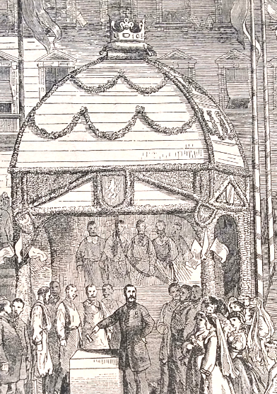
Nineteenth-century Czech nationalists deployed a highly developed language of symbol and ritual in the political performances to protest the Compromise of 1867. They asserted the status of the Kingdom of Bohemia as the equal of Hungary within the composite Habsburg realm, and simultaneously as a Czech state. One of the most significant single events among these acts of protest was the elaborate celebration of the laying of the foundation stones for the Czech National Theater on May 16, 1868. Combining popular pilgrimage, historical re-enactment, masonic ritual, and formal banquet, the festivities constituted a multifaceted performance. The cornerstone festivities helped fix in Czech nationalist practice the symbolic and ritual elements that served these ends, and their fiftieth anniversary was marked even during the waning months of the First World War.

10 July 2019 / 1:00 pm / Wood Room (OK 406)
Victoria University, Wellington

This event is free and open to the public

