"The Weight of Greatness—Tang Xianzu and William Shakespeare"
Talk for opening event of exhibit "Dialogue Across Time and Space" Exhibit at Paramount Theatre, Wellington, NZ on 23 September 2016

by Megan Evans, Senior Lecturer, Victoria University of Wellington, Theatre Programme

We are gathered to honour the great playwrights, Tang Xianzu and William Shakespeare and I will be discussing perhaps the greatest works by these playwrights: William Shakespeare's Hamlet and Tang Xianzu's Peony Pavilion. We will begin with a short clip from Peony Pavilion, performed in the classical Chinese opera form called kunqu—which was prominent during Tang's lifetime, and still performed today. The clip is from the recent 'Youth Edition' adapted and directed by Bai Xianyong.

For those in the audience unfamiliar with the plot of Peony Pavilion, here is a brief summary:
A beautiful young girl named Du Liniang has lived all her life within the walls of her family compound. One spring day she goes for a walk in a glorious secluded garden with her maid. The experience awakens a deep longing in her, She worries: "The green springtime of my own life passes unfulfilled…O pity one whose beauty is a bright flower, when life endures no longer than a leaf on a tree!...." (Tang, p. 46). In this state of longing, she falls asleep and has a dream, and in the dream she is visited by a handsome young scholar called Liu Mengmei….[VIDEO excerpt from 'The Interrupted Dream" scene].

Waking to an empty reality, she pines away for her dream lover, becoming ill, and after painting a self-portrait, she eventually dies of a broken heart. But she continues to long for Liu Mengmei even after death and convinces the underworld judge to set her free to wander in the human world in search of him. Later Liu Mengmei, who does in fact exist, arrives on the scene, finds the self-portrait and falls in love with Liniang's image. Du Liniang's ghost visits him and convinces him to exhume her body, and bring her back to life. They elope, and after many trials, Du's father finally comes to accept that Liniang is not a demon, but actually his daughter brought back to life. He accepts the marriage, so that the lovers can live happily. In his preface to Peony Pavilion, Tang Xianzu says: "To be Du Liniang is truly to have known love….Love is of a source unknown, yet it grows ever deeper. The living may die of it; by its power the dead live again."

- In this conversation across time and space, between Tang and Shakespeare, we can see in Du Liniang's quest for love strong enough to bring life after death, something of Tang's answer to the great question of Shakespeare's Hamlet: "Why life? …To be or not…" Hamlet continues:
To die, to sleep—
To sleep, perchance to dream—ay there’s the rub,
For in that sleep of death, what dreams may come,
When we have shuffled off this mortal coil,
Must give us pause; ….
the dread of something after death,
The undiscovered country… (Act III, Scene i)

For those unfamiliar with the plot of Hamlet, here is a brief summary: In Shakespeare's Hamlet, death begins and ends the play. Hamlet has come home on news of his father's death. He finds his uncle Claudius on his father's throne and already married to his mother, Gertrude.
His father's ghost visits Hamlet, saying he was murdered by Claudius. Hamlet promises to avenge his father's death, but is unsure whether a ghost can be trusted. He decides to investigate further. He puts on an 'antic disposition', playing on the edge of madness, he berates his girlfriend Ophelia—telling her famously: 'get thee to a nunnery', rather than breed more sinners such as all men are. In the 'closet scene' he berates his mother for forgetting King Hamlet, and remarrying so quickly to Claudius. Thinking he hears Claudius spying on this conversation, Hamlet stabs a hidden intruder, only to discover it is Ophelia's father Polonius he has killed by mistake. The death of her father drives the sweet Ophelia truly mad and she drowns herself. Ophelia's brother challenges Hamlet to a duel, which Claudius has fixed to ensure Hamlet's death, using poisoned blades and a poison victory cup. Both young men are mortally wounded, Gertrude drinks the poison, Hamlet stabs Claudius, and then dies. We never learn what Hamlet discovers in that undiscovered country….death.

Both playwrights framed their famous lines within established poetic structures, but they were writing for actors to speak and sing their words in front of an audience, rather than for scholars to study them in a book (though scholarly study of both has certainly been richly rewarded). Both playwrights were writing for strong performance conventions that influenced the structuring of the unfolding drama:

One of my favourite staging conventions shared by Tang and Shakespeare is that they were both writing for an essentially bare stage. The playwright's words plus the actors' embodied expression combine with audience imagination to create the aesthetic event—a highly theatrical, free flow of time and place, where anything can happen.

Scholars of Chinese theatre have called this 'suppositional staging': the actor is 'pointing at' rather than directly representing what there is to know about the fictional world of the play;
Shakespeare scholars sometimes speak of 'acoustic scenery'. In opening the play Henry V, shakespeare's Chorus urges the audience: "And let us ciphers to this great accompt,/On your imaginary forces work.…/ Think when we talk of horses, that you see them /Printing their proud hoofs i'th' receiving earth (Prologue)

image source:
http://shax.blogs.wm.edu/2012/07/19/o-for-a-muse-of-fire-henry-v-at-the-globe/

In a Chinese opera version of Hamlet, the actor can use a stylized prop horse whip, conventionalised movement, and percussion to convey the prince travelling on horseback to the place haunted by his father's ghost.

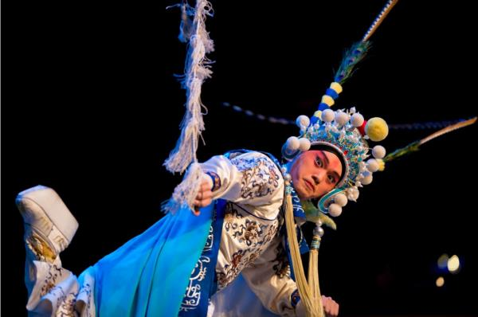

Fu Xiru as Prince Zi Dan
Shanghai Peking Opera Theatre, The Revenge of Prince Zi Dan
Image source: http://news.yorkbbs.ca/event/2014-03/1438038.html

As Du Liniang and her maid, walking in the garden—performers combine Tang Xianzu's glorious words, with their highly stylized song and movement, to evoke the beautiful scene in their audience's imagination: “Streaking the dawn, close-curled at dusk,/ Rosy clouds frame emerald pavilion;/ fine threads of rain, petals borne on breeze,/ gilded pleasure boat in waves of mist:/ glories of spring but little treasured/ by screen-secluded maid” (Tang, p. 44-45).

2014 Performance of Peony Pavilion in New Delhi
Image source: http://english.cri.cn/12394/2014/12/14/3941s856438.htm

Both writers worked closely with the actors. Shakespeare wrote for actors he knew, including the boys and young men who played the female roles. We don't know very much about the specific vocal or physical qualities these actors employed. But we do know that many of Shakespeare's female roles have limited stage time, perhaps because the actors playing them were young apprentices.

Images sources:
https://emerrmurphy.wordpress.com/2016/03/13/shakespeares-boy-players
http://www.chinaopera.net/english/catalog.asp?tags=The+Peony+Pavilion&page=2

Many scholars and contemporary theatre makers find the characters of Gertrude and Ophelia in Hamlet to be underdeveloped-- Including New Zealand playwright Jean Betts who titled her feminist adaptation of Hamlet, Ophelia Thinks Harder. Betts gives many of Hamlet's famous lines to Ophelia, who works through the challenges of her situation and arrives at a much more hopeful ending for the character, running away with Horatio to start a new life.

Encountering Shakespeare's Ophelia, we wonder how it is that she is brought so easily to madness and suicide. We wonder, what did Shakespeare's Gertrude know or guess about Claudius's plots. Both scholars and actors continue to debate these questions. I'll talk a bit more in a moment about how they were resolved in a recent Chinese opera adaptation.

Tang also worked closely with actors preparing to perform his plays. And while women were later temporarily banned from the Chinese stage, during Tang's life, same-sex troupes of both genders were common. A rich performance language was being developed that conveyed a character's gender to the audience but was independent of the performer's own age and gender. One of the earliest records of performance of Peony Pavilion in the kunqu style was by an all female company (Swatek 2002a, p. 5)—the record of that performance, a letter from a friend of Tang's, who was impressed by the ability of the two actresses to capture the emotional intensity of Du Liniang and her scholar-lover, Liu Mengmei. In the over 400 years since the play was written, many have commented on Du Liniang's thrillingly active participation in the creation of her own happiness, which is activated on stage through Chinese opera's rich performance techniques.

Given that Shakespeare's actors operated in a competitive commercial environment with little time for rehearsal, we surmise that Shakespeare wrote for a highly conventionalized staging process—actors knew set gestures and traffic patterns that carried from play to play. But much of this information has been lost to us.

Tang wrote for a tradition of indigenous Chinese music-drama, or xiqu, which is often incompletely translated as Chinese opera. The translation is incomplete because xiqu includes a synthesis of music, song, elaborately stylized movement, and acrobatics… a 'total theatre' exploiting a much more extensive range of performance skills than suggested by the English word 'opera', in which singing is the primary skill demanded of the performer. We know much more about these conventions because they have been passed down to contemporary performers over the generations.

(Image from Suzhou Kunqu Opera Theatre's Production [www.jsszkjy.com]).

Although Peony Pavilion is rarely performed in its 55-secene entirety, favourite scenes such as 'The Interrupted Dream' are frequently staged today in the Chinese opera style of kunqu, a form that was prominent during Tang Xianzu's life and has seen a contemporary resurgence in 21st century China.

So what happens when great works such as these travel across time and space to new historical, cultural and performance contexts? Clearly some essence or spark ignites a new artistic drive for artists in the new context.

Fu Xiru as Prince Zidan
2005 Shanghai Jingju Theatre Company's adaptation

David Tennant as Hamlet
2008 Royal Shakespeare Production

(Image sources:
https://www.chicagoshakes.com/plays_and_events/zidan and
https://www.rsc.org.uk/hamlet/past-productions/gregory-doran-production-2008)

Another thing that can happen is that some of the weight of reverence for the works and their authors can fall away, allowing for new aesthetic insight, and offering audiences fresh experiences of a classic they thought they knew.

In 1998 avant garde director Peter Sellars collaborated with Chinese xiqu artist Hua Wenyi and composer/conductor Tan Dun on a postmodern production of Peony Pavilion. In part motivated by the idea of Chinese opera as a 'total theatre' encompassing music, singing, dance, acrobatics, Sellars cast three pairs of actors in the leading roles—Hua Wenyi (using kunqu performance conventions and speaking and singing in Chinese) and contemporary dancer Michael Schumacher (no speech); Lauren Tom and Joel de la Fuente, speaking in English and performing in the style of western realism; Western style opera soprano Ying Huang and tenor Lin Qiang Xu who sang in English the operatic score composed for the second part of the production by Tan Dun.

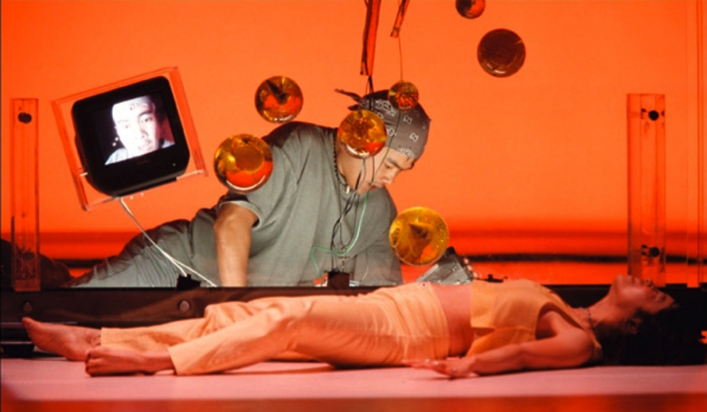
Lauren Tom as
Du Liniang &
Joel de la Fuente
as Liu Mengmei

Photo by Marc Enguerand
(image source:
http://www.festival-automne.com/edition-1998/peter-sellars-peony-pavilion)
For additional images of the production see also, Swatek 2002b).

In 2005, Shanghai Jingju Theatre Company staged a version of Hamlet called The Revenge of Prince Zi Dan, adapted by playwright Feng Gang, directed by Shi Yukun, music by Jin Guoxian. Writer Feng Gang explained: "We specifically designed this play for foreign audiences,” “We want to take Chinese opera overseas, but our traditional plays, while very eye-catching, were incomprehensible to foreigners.", Thus their goal was to use this western classic to help make xiqu more accessible for a global audience. But it has also been very successful in China.
The production continues on the company's repertoire and is touring this month in the USA as part of the global commemoration of Shakespeare's death.

The production strips away many of the confusing elements of Shakespeare's plot, making innovations to Shakespeare's classic in order fully to exploit the rich tradition of xiqu staging techniques. As in Shakespeare's version, the ghost of the recently dead king has been sighted. Prince Zi Dan travels to that location, where he encounters the Guardian of the underworld and several Ghost Guards escorting the ghost of the dead king.

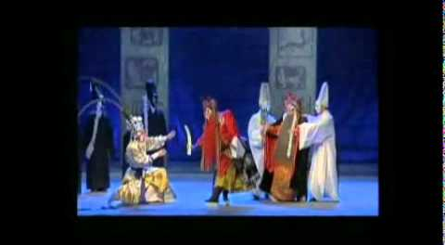
(for Edinburgh Festival promotional video see: https://www.youtube.com/watch?v=dP6I6F2DYLU)

The production incorporates many of the performance techniques used for the underworld judge of Peony Pavilion, including breathing sparks. The guardian mediates the encounter between Zi Dan and his Father's ghost, and provides opportunity for an exciting movement sequence as he separates Zi Dan from the ghost, who must return to the underworld.

In discussing his goals with the post-modern Peony Pavilion, Peter Sellars praised the integration of tradition through Hua Wenyi's skill and American-born composer Tan Dun's avant-garde direction. To frame this adventurous reworking of Tang's classic, Sellars added many contemporary elements, including a set with multiple television screens. He turned Du Liniang's self-portrait into a video blog. Lauren Tom played Lianiang as a petulant, rebellious teenager (Swatek 2002b, p. 152). The implied sexual encounter between Liu Mengmei and Du Liniang's ghost was symbolized with intricate handplay inspired by xiqu gesture (Swatek 2002b, Plate 5).

In stripping away much of the confusing subplots of Shakespeare's Hamlet, Revenge of Prince Zi Dan brought clarity and strength to the female roles: The Ophelia character, Yin Li, is given an extended aria—her intricate movements activate both our sympathy for the character and our appreciation of the actress's skill. This combination perhaps adding complexity and agency to our perception of the character.

image source: http://news.yorkbbs.ca/event/2014-03/1438038.html
text transcribed from DVD subtitles

With similar clarity, the production allows Zi Dan's mother a much more active engagement with the unfolding events. We see her overhearing the plot of her new husband to orchestrate the death of her son during the final duel. She is then given an extended aria/soliloquy. Alone onstage, she reveals how she regrets her deeds and will sacrifice herself to avert tragedy. In the final scene, she knowingly takes the poison cup, hoping to spare Zi Dan's life. Shakespeare's Gertrude has no soliloquy, we know she regrets, but we are not sure how much she knows or what she wants. As in Shakespeare's version, the jingju production ends with a thrilling fight scene and many deaths. But in both Shakespeare's play and the Chinese adaptation, witnesses remain offering some hope that in future such tragedy might be averted.
Image sources:
http://www.chicagoreader.com/chicago/hamlet-the-revenge-of-prince-zi-dan
http://www.dailymail.co.uk/news/article-3211021

With such radical changes to these revered classics, how have the productions been received? Opera News found 'a frustrating evening of multi-culti overkill'(Opera News). More positively, the Daily Telegraph called it an intelligent and often strikingly beautiful fusion of the ancient and the modern while also capturing the piece’s trippy atmosphere and highly charged sensuality" (Spencer 1988).

About the Jingju adaptation, The Telegraph found a "fantastical, free-wheeling re-interpretation gradually gave way to a sense of cultures colliding rather than integrating, of Shakespeare holding the genre’s extraordinary mix of elements in check" (Moore 2011). But for The Guardian, it was: “An evening that makes you sit up, look and listen afresh at a familiar story…It feels both exotic and familiar, ancient and strangely modern, and though this is a show that defies all western theatrical traditions, its strangeness becomes compelling. Shi Yukun's staging is clean and spare, allowing the rich rituals of the Peking opera tradition to flourish” (Gardner 2011).

Erika Fischer-Lichte from the International Research Centre on Interweaving Performance Cultures, talks about the emotional community that is created during a live performance and its potential for a transformative encounter. Perhaps this is especially true when the encounter occurs around a 'classic' text that carries in its wake a complex wealth of cultural understanding. Fischer-Lichte concludes:

"In performance, new forms of social co-existence are tried and tested....Moving between cultures is celebrated as a state of in-betweeness that changes spaces [and] disciplines...By interweaving cultures without erasing their differences, performances are able to constitute new realities—realities of the future, where the state of being in-between describes the ‘normal’ state of the citizens of this world" (2010, p. 6).

The convesation across time and space between Tang and Shakespeare continues through artistic exploration around the globe of contemporary theatre makers and writers who are inspired by these great works to re-imagine them in new contexts, to interweave craft and cultures, and to constitute new realities and futures. Including in New Zealand Poet David Howard's reimagining the action of Peony Pavilion to 1870s Otago Gold Rush.

THANK YOU.

References:

Betts, Jean & Wm. Shakespeare (2008). Ophelia Thinks Harder, Wellington, NZ: The Play Press.

Fischer-Lichte, Erika (2010). "Interweaving Cultures in Performance: Different States of Being In-Between". Textures: online platform for Interweaving Performance Cultures (www.textures-platform.com), August 11.

Gardner, Lynn (2011). "The Revenge of Prince Zi Dan – review", theguardian.com/culture, August 23.

Moore, Malcolm (2011). "Edinburgh Festival 2011: The Revenge of Prince Zi Dan – The secret of Hamlet in Chinese", telegraph.co.uk/culture, 15 August.

Opera News (1999). "From Around the World: Berkeley, CA (Review)", vol. 64, issue 1, p. 59 (July).

Swatek, Catherine C. (2002a). Peony Pavilion Onstage: Four Centuries in the Career of a Chinese Drama, Ann Arbor: Center for Chinese Studies/University of Michigan Press.

Swatek, Catherine C. (2002b). "Boundary Crossings: Peter Sellars's Productino of Peony Pavilion" in Asian Theatre Journal, vol. 19, no. 1, pp. 147-158.

Shanghai Jingju Theatre Company, The Tragedie of Prince Zidan, adapted forom William Shakespeare's Hamlet. DVD with English Subtitles. Available from
http://www.pekingopera.sh.cn/South-cont.aspx?id=10352

Spencer, Charles (1988). "Review," Daily Telegraph 14 Sept, accessed in Theatre Record, 10-23 Sept. 1998: 1194-95.

Tang Xianzu Peony Pavilion, translated by Cyril Birch (1980). Bloomington: Indiana University Press.

