TCHG315 and TCHG316
Graduate Diploma of Teaching Early Childhood
Te Whānau o Ako Pai | School of Education

PROFESSIONAL PRACTICE ADMINISTRATION PACKAGE

Student name:
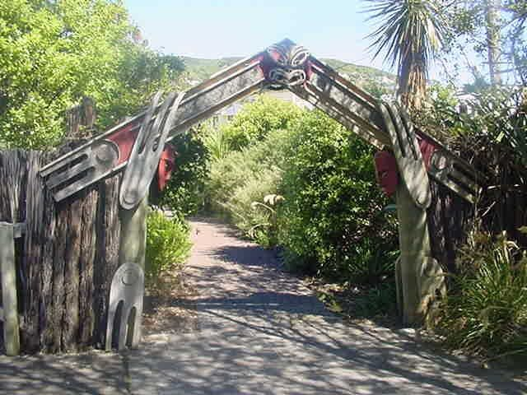



About This Package

This package identifies a range of administration tasks and duties undertaken by teachers in early childhood education centres. As part of your professional preparation as an early childhood teacher, you need to develop an understanding of the purpose of these tasks and of the systems used in early childhood education centres.

During your Professional Practices you will need to identify with your associate teacher a number of items on which to focus. You will need to gather evidence of discussion with your associate (or other relevant members of the teaching team) and of your involvement in the chosen tasks. This evidence will include your associate teacher ‘signing off’ against completed tasks; examples of forms and policies as well as brief notes on your discussions and involvement. It is not intended that you undertake large quantities of written work; rather that you gather information and examples that you can then draw upon in your future teaching.

You are required to develop an administration folder to use over your Professional Practices. You should keep this Administration booklet as part of your administration folder. You only need submit this Administration booklet to us after completing your final Professional Practice.

Administrative Tasks

Each of the following tasks must be completed during your programme of study (10-15 tasks in each Professional Practice, beginning with your second practicum). You need to discuss with your Associate Teacher (or other relevant staff member) the following:

- purpose of the administrative task
- procedure(s) used and rationale

Where possible, and appropriate, carry out the administrative tasks under the guidance of your Associate Teacher. Take brief notes on your discussions and, where appropriate, gather examples of the forms and resources used. Note that you will need your associate’s approval of the tasks to be covered on each Professional Practice.

Each of the tasks on the following pages should be completed over your practicums. Plan your selection of tasks with your Associate Teacher to ensure an even spread over your Professional Practices.

YOU SHOULD ENSURE THAT 10-15 OF THE TASKS HAVE BEEN COMPLETED AND SIGNED OFF DURING YOUR PROFESSIONAL PRACTICES.

Please keep this booklet in a safe place as you will be required to have all the tasks signed off across your Professional Practices. This booklet is only submitted to us after your final Professional Practice at the end of the year.

Criteria

- Individual items signed off by Associate Teacher with name of the centre and date task was completed.
- Brief notes recorded by student on discussion about, and involvement in, administration tasks.
- Where appropriate and relevant, copies of forms and policies collected and included in your folder.
- Student Teacher notes on Associate Teacher discussion.

Submission
Please either hand this administration package in or email to professionalpractice@vuw.ac.nz at the completion of your final Professional Practice 3. Any other documentation or artefacts should be kept by you in your folder.

TASK | Please enter name of centre, associate’s signature & date against each task when it has been completed
Attendance rolls, registers, signing in-sheets | Centre:  Associate Signature:  Date:
Admission procedures | Centre:  Associate Signature:  Date:
Budgets/funding – staff responsibilities | Centre:  Associate Signature:  Date:
Child behaviour management policy | Centre:  Associate Signature:  Date:
Child health – first aid/recording accidents, administering medication | Centre:  Associate Signature:  Date:
Child health – immunisation records | Centre:  Associate Signature:  Date:
Civil defence – fire and earthquake drill | Centre:  Associate Signature:  Date:
Communication with parents (e.g. noticeboard, newsletters, home visits) | Centre:  Associate Signature:  Date:
Complaints procedures | Centre:  Associate Signature:  Date:
Curriculum facilitation | Centre:  Associate Signature:  Date:
Development and review of centre philosophy | Centre:  Associate Signature:  Date:
Enrolment procedures  (pre-admission) | Centre:  Associate Signature:  Date:
ERO review process and report | Centre:  Associate Signature:  Date:
Excursions | Centre:  Associate Signature:  Date:
Fees/donations | Centre:  Associate Signature:  Date:
Fundraising | Centre:  Associate Signature:  Date:
Health & Safety Policies | Centre:  Associate Signature:  Date:
Information charts (e.g. toileting, sleeping) | Centre:  Associate Signature:  Date:
MOE returns | Centre:  Associate Signature:  Date:
Policy on Inclusion | Centre:  Associate Signature:  Date:
Prevention of child abuse policy | Centre:  Associate Signature:  Date:
Procedures for settling children into the centre | Centre:  Associate Signature:  Date:
Staff appraisals | Centre:  Associate Signature:  Date:
Staff professional development | Centre:  Associate Signature:  Date:
Staffing rosters | Centre:  Associate Signature:  Date:
Strategic/management plans | Centre:  Associate Signature:  Date:
Systems for reporting to parents on their child’s progress | Centre:  Associate Signature:  Date:
Transitions – within the centre | Centre:  Associate Signature:  Date:
Transitions – to school and/or other ECE centres | Centre:  Associate Signature:  Date:

