‘Black Shirts, Red Menace’
Croatian Separatist Terrorism and the Cold War
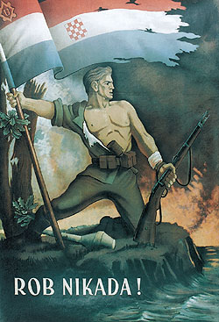
Mate Tokić of the Freie Universität Berlin will speak to the Antipodean East European Study Group about ideologies and terrorism among the Croatian Diaspora. All are welcome!
Tuesday 24 March – Wood Seminar Room (OK 406) – 4:30 pm


