‘Turkey for the Turks, Greece for the Greeks’
The 1923 Greco-Turkish Population Exchange
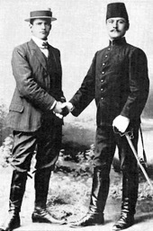
Gürer Karagedikli of Bilkent University, Ankara, will speak about the 1923 Greco-Turkish Population Exchange within the context of building nation-states in the Balkans. All are welcome!
Tuesday 28 July – Old Kirk Building (OK) 301 – 5 pm

