The “East-West” Discourse:
Symbolic Geography and its Consequences

20-21 March, 2010. Victoria University, Wellington, New Zealand.

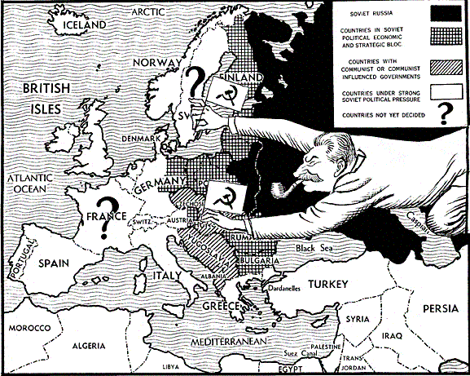

The Antipodean East European Study Group will host a conference attempting to ground the rhetoric of “East vs. West” in particular historical contexts and problematize its implicit assumptions. How does this contrast play out in specific places and times? What are historical actors attempting to accomplish when they invoke this binary dichotomy?

The conference will take place at the Kelburn Campus of Victoria University, in the Wood Seminar Room (OK 406). The keynote speaker is Charles Ingrao of Purdue University. For the full conference schedule with abstracts, see http://www.victoria.ac.nz/antipodean/upcoming-events.aspx



