Re-Imagining Borders:
Hungary and ‘Its Own’ Sub-regions

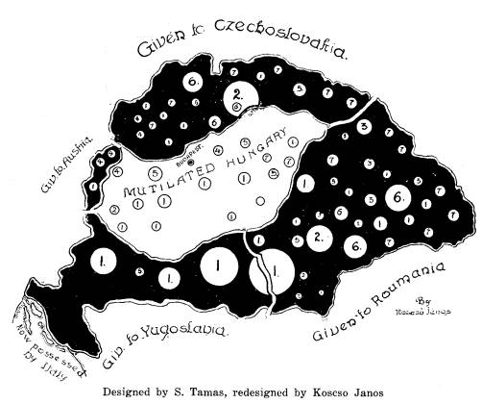

Robert Imre, University of Newcastle (NSW)

In its current form, the Hungarian nation-state constitutes a territory with a majority of Hungarian-speakers, with a complex mix of ‘ethnic origins.’ The development of the Hungarian nation-state presents a number of interesting problems for contemporary politics in that the borders have changed so often in the modern period. Multiple conceptions of what constitutes ‘Hungarian-ness’ dissolve the basic East-West divide, leaving instead complexities of ‘hinterlands.’

Victoria University, Kelburn Campus, Old Kirk 406 Wednesday, 10 February at 3:00 pm

