Metodija Koloski
President, United Macedonian Diaspora

“Integrating Macedonia into Global Institutions:
The Role of the Macedonian Diaspora”

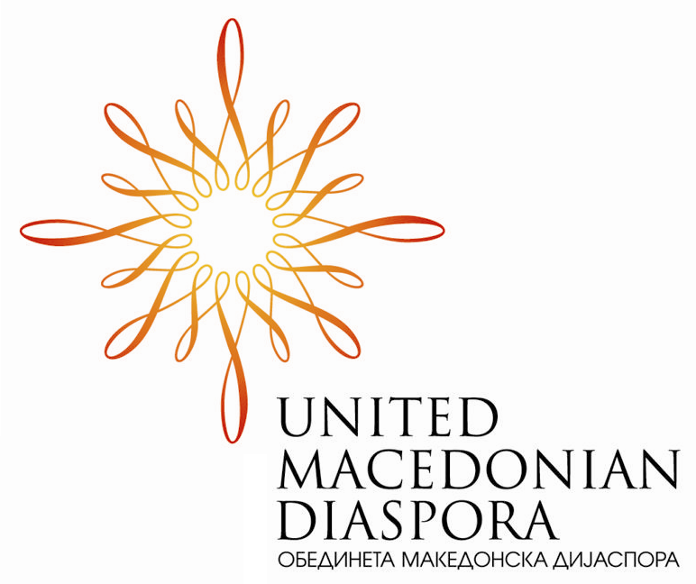

Koloski has written opinion pieces on Macedonia’s right to its name, minorities in South Eastern Europe, and NATO and EU membership for the Washington Times and the Journal Gazette. UMD is a non-profit, non-governmental organization which since 2004 has emerged as the leading provider of strategic advocacy and support to the Republic of Macedonia and Macedonian communities in Australia, Europe, and North America.

Wood Seminar Room (OK 406) at 3:30 pm 23 Feb, 2010

