National Bodies in Eastern Europe

28-29 August 2010
Victoria University, Wellington, New Zealand
Murphy Building 101

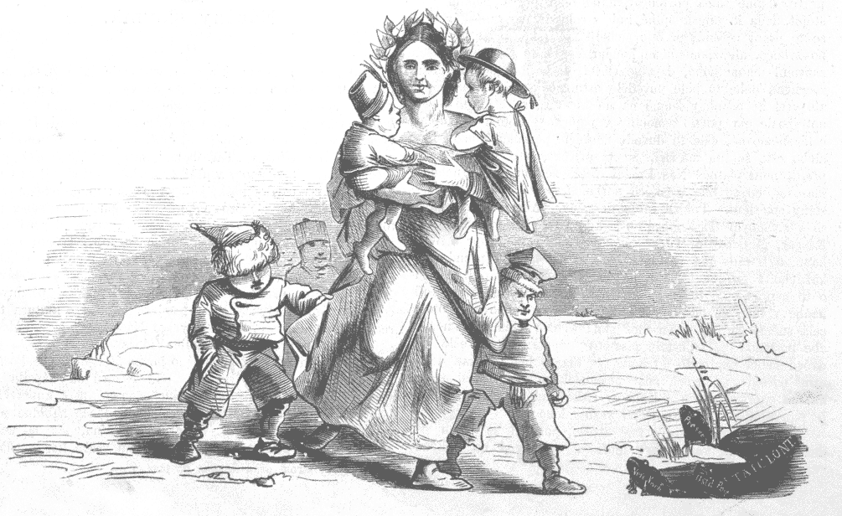
Organized by the Antipodean East European Study Group and the Russian Department at Canterbury University, Christchurch


SATURDAY 28 AUGUST

10:00 Welcoming Remarks (A. Maxwell, H. Mondry)

10:15 The female body in Poland
Jolante Mickutė
“Zionist Discourse on the Jewish Woman’s Body in Interwar Poland”

Abby Drwecki
“Body Projects and Women’s Empowerment in Poland”

11:45 Lunch break

13:00 National bodies in interwar Romania
Alexander-Peter Popescu
“Identity and Alterity in (A)romanian Nationalism in interwar Romania”

Michael Wedekind,
“The Mathematization of the Human Being: Anthropology and Ethnopolitics”

14:30 Coffee Break

10:15 Body Practices as nationalist practice
Sophia Kalogeropoulou
“Dancing Nationalism in the Balkans”

18:00 Conference Dinner

SUNDAY 29 AUGUST

10:15 Racial thinking and national bodies
Alexander Maxwell
“The Myth of Circassian Beauty”

Henrietta Mondry
“Ethnographic Costume without Racial bodies; the Case of K. Leontiev”

11:45 Lunch break

13:00 Sexuality and the national body
Takayuki Yokota-Murakami
“The Sexual Body in Exile: (White) Russian (Jews) in Manchuria and Japan”

Linda Galvane
“Japanese–Russian Mixed Bodies in Contemporary Russian Literature”
Conference Abstracts

Abby Drwecki (Indiana University)
“Body Projects and Women’s Empowerment in Poland”

Polish women’s participation in self-defense is an example of a “body project” undertaken with the aims of individualized empowerment and self-improvement. Polish women’s participation in self-defense courses represents a trend toward individuation in contemporary Polish culture and in post-socialist Eastern Europe more generally. That is, in this region there has been a tendency to emphasize improvement of the individual as the key to improvement of societies, economies and nation-states. This individuation, which implies attention to individual bodies as a strategy of social progress, dovetails with neoliberal capitalist social and economic policies embraced by the Polish government. Such an atomized conception of personhood leads to the promotion of an individualized philosophy of personal responsibility, allowing for the dismantling of the social safety net and the consumerist construction of identities. Even though self-defense participation is an individualistic means of empowerment for women, it can also be construed as an act of economic citizenship based on a construction of the economically disadvantaged as a violent Other.
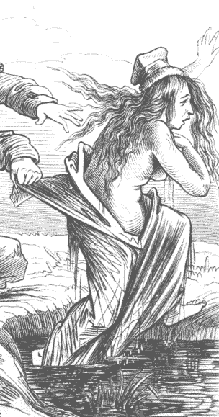
Linda Galvane (Osaka University)
“Japanese–Russian Mixed Bodies in Contemporary Russian Literature”

This paper explores the representation of the national self-identification process, its peculiarities and meaning through the characters of mixed national and racial origins in the contemporary Russian literature, examining the juxtaposition of Russian and Japanese nationalities. A short-story Captain Rybnikov by Kuprin, for example, depicts a Japanese spy disguised as a Russian, thus playing with a racial diversity of Russia. the novel Three Ages of Okini-san by Valentin Pikul is an attempt to represent the official ideology of Soviet Union that Russians are not concerned with racial differences. Contemporary Russian writers, such as Boris Akunin and Olga Lazoreva also have made attempts to represent Japan in connection with these issues in their own way. Olga Lazoreva’s trilogy The Russian Geisha also deals with the problematics of race and nationality.
Sophia Kalogeropoulou (Otago)
“Dancing Nationalism in the Balkans”

This paper examines the significance of folk dance performed in everyday life within communities, specifically in the Balkan region. It focuses on its role in nurturing a sense of ethnic belonging in its participants and enhancing their national identity. While folk dance acts as a uniting device bringing together members of ethnic groups, its innocent and celebratory nature can be transformed into a political ritual that exaggerates differences and projects chauvinism and nationalism. The dance of Zaloggo (1803), performed by 62 Greek women before they committed suicide in order to protect their ethnic identity and avoid enslavement by the Turks, has become an iconic representation of the Greek ethnos and its cultural values. Other examples are more recent, such as the use of folk dance as an image of nationhood during the dispute over the name ‘Macedonia’ after the break-up of Yugoslavia, and folk dance in the line of war in former Yugoslavia during the conflicts of the 1990s.

Rosalind Marsh (University of Bath)
“Gender, Citizenship and Empire”

This paper attempts to define the three terms in order to explain the assumptions that lie behind my treatment of this new subject; to suggest how these concepts might interact in post-Soviet society and culture, to discuss some of the theoretical and methodological problems they raise; and to present a brief exploration of how these issues have been treated in post-Soviet literature by both men and women, particularly in writings of the twenty-first century. Women writers in post-Soviet Russia have had some success in challenging the traditional ‘symbolic order’ in their culture as it refers to women. Their alternative depictions of women’s identities, sexuality, motherhood and family relationships and the tolerant views of national, ethnic and religious identities espoused by such writers as Svetlana Vasilenko, Nina Gabrielian, and Liudmila Ulitskaia have been more than matched by the resurgence of traditionalist, reactionary views of gender in male-dominated culture, politics and society.

Alexander Maxwell (Victoria, Wellington)
“The Myth of Circassian Beauty”

During the nineteenth century, Central Europeans, Western Europeans and Americans believed that Circassian women possessed extraordinary beauty. Since most imperial stereotypes saw foreign women from impoverished non-Europe as ugly or uncultivated, the myth of Circassian beauty deserves investigation, and appears to have two main explanations. Firstly, so-called racial scientists proposed Circassia as a putative Aryan homeland. Secondly, the fact that women in the Ottoman slave markets frequently came from Circassia meant that Circassians featured prominently in European harem fantasies.

Jolante Mickutė (Indiana)
“Zionist Discourse on the Jewish Woman’s Body in Interwar Poland”

The majority of scholarly debates on the Jewish varieties of nationalism focus on the Jewish man’s role in the (re)building of the Jewish homeland and his body in the regeneration of the Jewish nation. My talk discusses Zionist politics surrounding the Jewish woman’s body and sexuality in this rebirth process as well as in the formation of a modern Jewish identity in interwar Poland. It thus explores Jewish patriarchal structures and the discursive power and reach of Zionist ideology.

Henrietta Mondry (Canturbury, Christchurch)
“Ethnographic costume without racial bodies; the case of K. Leontiev”

Aesthetic views on ethnic diversity without the idea of race occur in the work of the nineteenth century Russian writer, thinker and diplomat Konstantin Leontiev. Leontiev was a medic by education and created an original view on history of society modelled on biological ideas. Although a conservative thinker, he praised the idea of ethnic diversity without applying the idea of race. He acquired his ethnographic experience as a Russian diplomat in the Balkans where he came into contact with Greeks, Turks, Slavs, Albanians, Jews and Roma Gypsies. Leontiev's representation of ethnic appearances in costume and dress is based on his reading of the Swiss physiognomist Lavater. But while Lavater is viewed as a precursor of racialism, Leontiev's views on appearances are overtly non racist, and are driven by "aesthetic attitude" towards history.

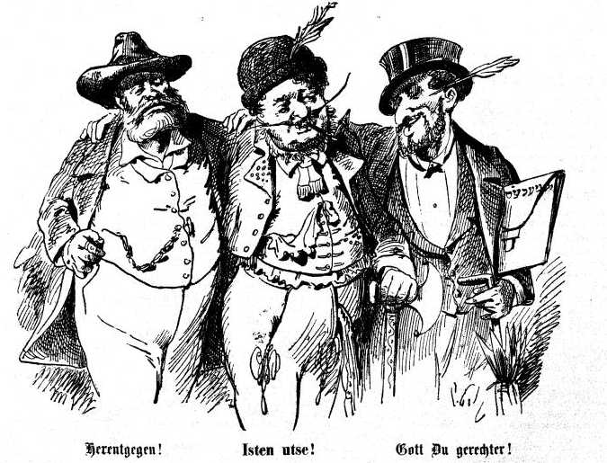

Alexander-Peter Popescu (University of Graz)
“Identity and Alterity in (A)romanian Nationalism in interwar Romania”

Within the Iron Guard and also among the Romanian and Aromunian elite in Greater Romania, we find a certain instrumentalization of ideological propaganda concerning stereotyped images of the more or less overrated self and of the mostly negatively seen other. The Balkan-Romanic Aromunians, coming between 1923-1940 as Romanian colonists in the Cadrilater, were recruited there and also in Bucharest by the Iron Guard and thus formed a very influential core and also violent circles, where structural and mental forms of a body-oriented conscience dominated the frame. Descending from the mountains environment of the Balkans, the Aromunians described themselves as strong-bodied, pure, heroically fighting men with a dislike towards the stereotipically placid, unpure and not warlike Dacian-Romanian peasants or workers from urban areas, which implies divergent concepts for the course of the construction of a healthy, pure and male national body. The Aromunians’ avant-garde function in the Iron Guard is set precisely within this context.

Michael Wedekind (University of Muenster)
The Mathematization of the Human Being: Anthropology and Ethnopolitics

Romania’s nation building process has been decisively influenced by what was considered the Western European model of “ethnically homogeneous nations”. Especially after 1918 and the birth of “Greater Romania”, the country’s elites were intended to “homogenize” the ethnically strongly mixed population. The paper examines the role played by Romanian sociologists and bio-scientists in forming a national identity, in empirically “measuring” the new nation state as well as in developing strategies for the integration, assimilation and political guidance, or exclusion and extermination respectively, of ethnic and social groups. It highlights the influence these scholarly elites had on political decision making and population policy, on ethnopolitics, spatial planning and social engineering in the lower Danubian Basin before and during the Second World War.

Takayuki Yokota-Murakami (Osaka University大阪大学)
“The Sexual Body in Exile: (White) Russian (Jews) in Manchuria and Japan”

This paper attempts to explore the specificity of the formation of the national identity among the White Russians in Manchuria and Japan through such sexual contacts, analyzing some literary works by the contemporary Japanese authors who had such liaisons. By these authors the bodies of the White Russian women were represented stereotypically: having blonde hair and blue eyes. Such aestheticization was endorsed by the familiarity of some of the Japanese writers with fin-de-siècle and avant-garde Russian literature. For instance, Jiromasa Gunji in his The Diary with Blonde Women frequently quotes Aleksandr Vertinsky, himself a poet in exile, as expressing an innermost essence of the White Russian women, authorizing their decadent, desperate beauty and licentious sexuality.

