Poland, Ukraine and Lithuania:
Relations in the aftermath of EU Enlargement

Des Brennan, Canterbury University, Christchurch

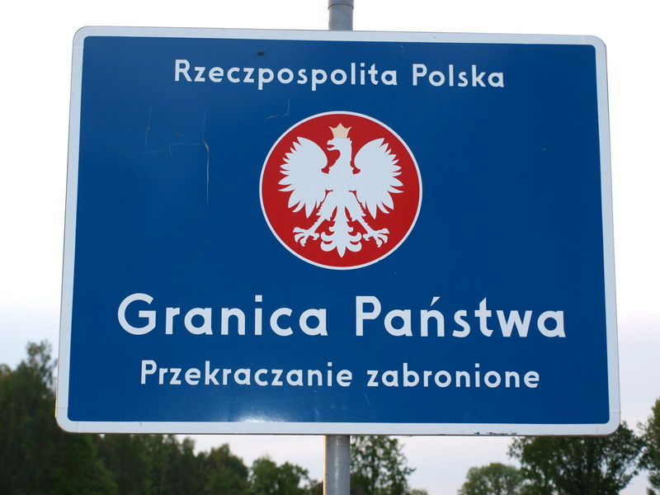

Twenty years ago, Poland and Lithuania set out on a path that took them out of the Soviet Bloc and eventually into the EU and Nato. The 2004 accession of Poland and Lithuania to the EU has improved relations between the two countries. The eastward shift of the EU border has markedly affected relations between the two countries and Ukraine. Poland and Lithuania are determined that Ukraine be established on a path that will eventually lead to its accession to the EU and Nato. They find opposition to this goal among many in the western EU states and, especially, in Russia. While citizens of western Ukraine mostly favour closer ties between Ukraine and Europe, many in eastern Ukraine prioritise relations with Russia. One challenge is to ensure Ukraine’s continued territorial integrity in the face of Russia’s manoeuvring.

Join us in the Wood Seminar Room (OK 406) at 10 am, 10 September, 2009!



