Stateless in Europe
Legal Faces of Nationalism in Estonia and Slovenia
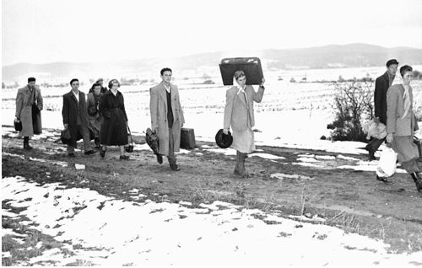

Caroline Sawyer, Victoria University (Law)

Part of the reordering of Eastern European following the end of the Cold War was the redrawing of human boundaries. Some people found that the countries in which they were leading long-established lives no longer regarded them as citizens. Caroline Sawyer from VUW Faculty of Law will discuss the findings of a comparative empirical project that looked at the experiences of parts of the populations of Estonia and Slovenia after the breakdown of both the Soviet Union and Yugoslavia. This event is free and open to the public.


12:00 noon Tuesday 18 May, Wood Seminar Room (OK 406)
Kelburn Campus, Victoria University Wellington

