The History Programme Research Seminar Series presents:

Poetic Correspondences:
Arkadii Dragomoshchenko & Lyn Hejinian

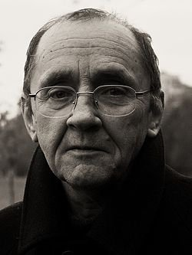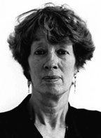

Jacob Edmond (University of Otago)

Developing through the perestroika period and concluding in the early 1990s, Russian poet Arkadii Dragomohshchenko’s correspondence and collaboration with US poet Lyn Hejinian coincided with the period of political and cultural flux that climaxed in the collapse of the Soviet Union and the end of the Cold War. What Hejinian would later call the “geo-politics” of her “alliance” with Dragomoshchenko affects and sometimes obscures the singularity of this and other very personal cross-cultural encounters and artistic collaborations. It raises a question that increasingly preoccupies scholars of both literature and history: how can we reconcile the generalized abstractions of language, culture, society, and history with a particular text and with the person who writes it?

12:00 noon Friday 9 Sept, Wood Seminar Room (OK 406)
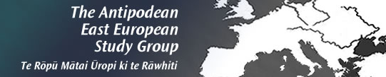
Kelburn Campus, Victoria University Wellington

