Sexualities & Science in Eastern Europe

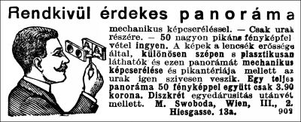
“Extremely interesting panorama ... only for gentlemen”

Sexuality pervades human experience, but has only in comparatively recent times been the subject of scientific investigation. This conference examines the development of sexology and sexual psychology from the nineteenth century to the present, with a special emphasis on Eastern Europe (including Russia), the region which produced such “seminal” figures as Sigmund Freud, Károly Mária Kertbeny, Aleksandra Kollontai, Richard von Krafft-Ebing, and Leopold Sacher-Masoch. Topics of possible interest include, but are not limited to, sexologists, sex advice manuals, sexual psychology, sexual violence experts, eugenics and racial purity, the social science of prostitution, and experts in trafficking and sex work. We are open to scholars working in literature, sociology, history, anthropology, psychology, and cultural studies.

Potential participants should contact Alexander Maxwell@vuw.ac.nz

The conference will take place on 27-28 March 2011
at Victoria University, Wellington, New Zealand.

Picture taken from: Dóra Vargha, “A bűn medikalizálása [The Medicalization of Sin]” Budapesti Negyed, vol. 13, no. 1-2 (2005) URL: <http://epa.oszk.hu/00000/00003/00034/vargha.html>.

