Science and Nationalism in the Habsburg Monarchy

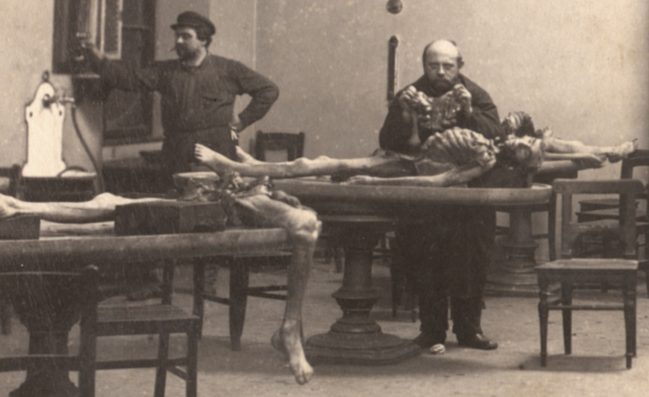
Tatjana Buklijas
Liggins Institute, University of Auckland

Science is often thought of as a body of universal and objective knowledge immune to local political and cultural pressures, and scientists who openly endorsed, and whose work was endorsed by, political regimes, have been viewed with suspicion. Yet historians of science have long argued that the scientific content is under direct social influence. The rising movements for national emancipation affected science in the Habsburg Monarchy. My talk focuses particularly on the University of Vienna, a microcosm of the Habsburg Empire, to ask how the emergence of nationalism affected medical/scientific disciplines that appear apolitical at first glance.

Friday July 27, 2012 at 12:10 pm
Wood Seminar Room (OK 406)

