1918: National Councils
and Great Powers

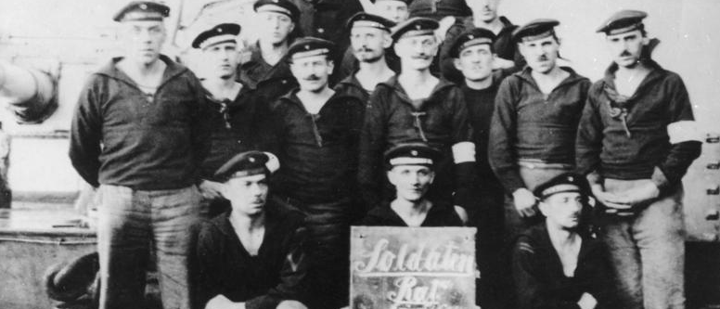

During the closing months of the First World War, all across the former Romanov, Hohenzollern and Habsburg Empires, new ideas about legitimate political power flourished. Most political entrepreneurs drew rhetorical inspiration from either Wilson or Lenin: the slogans “national self-determination” and “all power to the Soviets” arguably characterize the era. A central institution of the postwar environment was the council, either a “national council” or a council of workers, peasants, and/or soldiers. Most were short-lived, but a few won recognition as a legitimate government. Councils responded to local political constituencies, but also appealed to the great powers, which could potentially confer legitimacy or even provide military or material assistance.

The conference takes place in Wood Seminar, Victoria University, 11August 2012. There will be no registration fee: the event is free and open to the public.

Conference Abstracts

Keynote Speaker: Martin D. Brown
Richmond, the American International University in London
“ ‘Perfidious Albion’ and the making of Central Europe:
British Foreign Policy and East-central European Borders”

Between 1919 and 1975 British foreign policy had a direct impact on the making and unmaking of East-central Europe’s borders. British authorities were in a position to repeatedly bestow and withhold recognition of national councils, governments in exile, and political boundaries. British decisions were frequently at odds with the national aspirations expressed on the ground, reinforcing stereotypes of ‘perfidious Albion’. Officials in Whitehall obviously viewed their decision-making as well informed, but what little attention they gave to Central European affairs was shaped by the overriding concerns of an Empire in decline, an obsession with maintaining the ‘balance of power’ on the Continent, and by the constraining influences of geography. During the 1919 Paris Peace Conference, political elites in East-central Europe were so engrossed by the Wilsonian rhetoric of ‘national self-determination’ they failed to grasp that the Great Powers’ were primarily interested in the creation of a viable bulwark against Bolshevism, rather than in the ‘fairness’ of the settlement. Navigating this gap between idealism and realism characterised British policy making toward East-Central Europe both before and after 1919. While Whitehall’s vacillating policies towards East-central Europe seemingly defy any form of logical or coherent explanation and repeatedly appeared arrogant and ignorant to many from the region, they stemmed from its continued application of imperial policies.

Sacha Davis, University of Newcastle (NSW)
“Negotiating self-determination without statehood:
the Transylvanian Saxon Volksrat”

Following the collapse of the Habsburg Empire in 1918, the (Transylvanian) German-Saxon Volksrat took steps to fill the political vacuum, organizing citizens’ militias to keep the peace in towns with large Saxon communities, and asserting the right to self determination on the international stage. However, the 230,000 strong Saxon community failed to form a majority population in most of their areas of settlement, and in any case were too small to form an independent state. The Volksrat sought to secure national self-determination within the emerging framework of nation states, first negotiating for territorial autonomy in Hungary, arguing for a canton gerrymandered to maximize Saxon influence. A gerrymandered canton model suited Hungarian nationals and Saxons alike, as both formed minority populations within Transylvania. Romanian nationalists were unwelcoming of a canton system, which poorly served the majority Romanian population. Once Transylvania came under Romanian rule, the Volksrat negotiated (largely unsuccessfully) for predominantly non-territorial, cultural autonomy within Romania.

Andrew Francis, Wellington
“The Auckland Yugoslav Committee and their Search for Recognition:
Dalmatians in New Zealand, 1914-1920.”

This paper examines the effects the European war had on New Zealand’s Dalmatian settler communities. Aware that their status within New Zealand would be altered as a result of overseas developments, community leaders formed councils, committees and delegations to ensure their views were heard. With the creation of the new kingdom of Serbs, Croats and Slovenes in October 1918, they petitioned the New Zealand government to have recognised their new status as Britain’s allies rather than the ‘Austrian’ enemy aliens they had been categorised as during the war. Though this initially proved unsuccessful, it was one of several campaigns the dominion’s Dalmatians undertook to gain recognition for their changing national status. While this period is generally characterised as a time of burgeoning Croatian nationhood in New Zealand’s Dalmatian settler communities, not all settlers supported the creation of their new kingdom in southern Europe.

Alexander Maxwell, Victoria University, Wellington
“Holding the National Card:
The Entente, Czechoslovakia, and the Lusatian-Sorbian Narodny Wubjerk”

In November 1918, a Lusatian-Sorbian national council, the Narodny Wubjerk, led by Arnošt Bart-Brězynčanski, demanded Sorbian independence. When the Entente showed little interest in Sorbian nationalist aspirations, Bart turned to the Czechoslovaks. Czech patriots had long expressed interest in Sorbian questions, and several had imagined Sorbs as part of a greater Czechoslovak ethnic collective. When presenting Czechoslovak claims to the Entente, however, Edvard Beneš conspicuously refrained from demanding Lusatia for the new republic. Political opportunism explains Czechoslovak restraint.

Matthew Vink, Victoria University, Wellington
“The movement dictated by the empty stomach”:
Vorarlberg’s Nationalrat, Switzerland, and the Paris Peace Conference

The western-Austrian province of Vorarlberg was thrown upside-down by the events of 1918-1919. Vorarlberg’s Nationalrat, led by Otto Ender, declared its independence in November 1918, and led a Vorarlberg-wide campaign for political union with Switzerland. This campaign culminated in a referendum on 11 May 1919, in which 81 percent of the population voted in favour of union with Switzerland. Otto Ender travelled personally to Paris to have the referendum results recognised internationally. Delegates at Paris initially supported the union with Switzerland, but Austrian President Karl Renner persuaded them to force Switzerland to abandon the plan. Newspapers in Vorarlberg and documentation compiled by the Paris Peace Conference suggests that nationalist ideology played only a limited role in determining Vorarlberg political loyalties. Vorarlbergers who campaigned for union with Switzerland were motivated instead by practical economic considerations: to the cost of living, currency stability, pensions, and the availability of food.
Conference schedule

10:00 am Ignored Irredentists
Alexander Maxwell
“Holding the National Card:
The Entente, Czechoslovakia, and the Lusatian-Sorbian Narodny Wubjerk”

Matthew Vink
“The movement dictated by the empty stomach”:
Vorarlberg’s Nationalrat, Switzerland, and the Paris Peace Conference

11:30 am Keynote address
“ ‘Perfidious Albion’ and the making of Central Europe:
British Foreign Policy and East-central European Borders”

Dr. Martin D. Brown
(Richmond, the American International University in London)

12:30 Lunch break

1:30 pm National Councils and Minor Entente Powers
Andrew Francis, Wellington
“The Auckland Yugoslav Committee and their Search for Recognition:
Dalmatians in New Zealand, 1914-1920.”

Sacha Davis, Newcastle (NSW)
“Negotiating self-determination without Statehood:
The Transylvanian Saxon Volksrat”

6:00 pm Conference dinner “Floriditas”
161 Cuba Street
Tel: (04) 381-2212

