Tonics, Elixirs and Poisons:
Psychoactive Substances in
European History and Culture

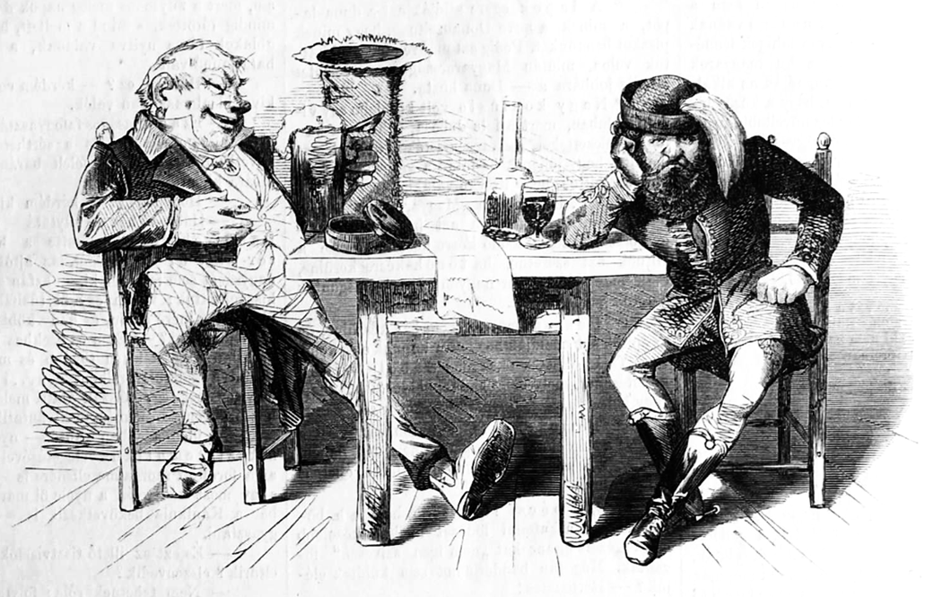

Saturday 8 September 2012

Psychoactive substances, whether narcotics, stimulants or hallucinogens, affect their users as individuals, yet their social context informs their cultural significance. At different times and in different places, different substances have become a locus of fascination or anxiety, praise or opprobrium, patriotism or prohibition.

Victoria University, Kelburn Campus, Von Zedlitz 606
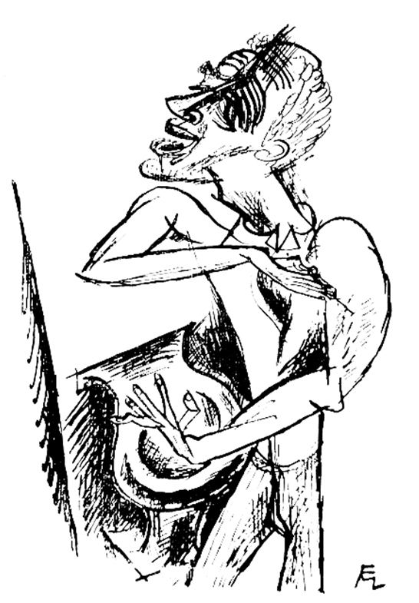
Conference Schedule

9:20 am Conference Welcome

9:30– 10:50 Stimulating literary production
Luc Arnault (Victoria, Wellington)
“The River of Alcohol, the Junkies and the Fuzz:
Psychoactive Substances in James K. Baxter’s Poetry.”

Marco Sonzogni (Victoria, Wellington)
“Cigars and Cigarettes in 1930s Italy: a Poetic Perspective.”

11:00 – 12:20 Hungarian Spirits and the Hungarian Spirit
Alexander Maxwell (Victoria, Wellington)
“Hungarian Wine, Slavic Brandy? Alcohol in Reform-Era Hungary.”

Rob Imre (Newcastle, NSW)
“Regulating, Colonising, and Decolonising Pálinka in modern Hungary.”

12:20– 1:00 pm Lunch break

1:00 – 3:00 pm Psychedelic experiences in German Literature
Kerry Nitz (Victoria, Wellington)
“Alcohol in the Early Novellas of Hermann Stehr.”

Richard Millington (Victoria, Wellington)
“Max Pulver’s Himmelpfortgasse: Cocaine in Interwar Vienna.”

Chris Rudge (University of Sydney)
“LSD, Mescaline and the Experimental Imaginary in European history.”

6:00 pm Conference Dinner

Conference Abstracts

Luc Arnault (Victoria University)
“The River of Alcohol, the Junkies and the Fuzz: Psychoactive Substances in James K. Baxter’s Poetry.”

James Baxter, “New Zealand best-loved poet,” struggled with alcoholism throughout his life. In the context of the late 1960s, he repeatedly referred to psychoactive substances in his poetry, noticeably in Ballad of The Junkies and the Fuzz (1970). How do these substances transpire into his oeuvre? How are they represented? What is their significance? Not only a sharp social commentator of his time and a poet capable of deep abstraction, he also took action. Just before founding a commune in Jerusalem, where both Maori and Pakeha lived according to the spiritual principle of aroha and where he counselled those suffering alcoholism, he attempted to establish a Narcotics Anonymous organisation in Auckland. How was this perceived by the general public? How did it affect his writing? His experiences as an alcoholic working with alcoholics and drug addicts supplied a useful and emblematic context in which human frailties were examined.

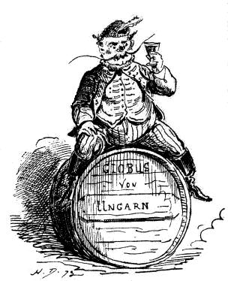
Rob Imre (Newcastle, NSW)
“Regulating, Colonising, and Decolonising Pálinka in modern Hungary.”

The production and distribution of illicit alcohol in rural Hungary is a key indicator of resistance to the modern state apparatus. Changes in the conception of the modern Hungarian citizen can be tracked through the illicit alcohol production and consumption, usually in the form of wine or a particular kind of brandy. Political anthropology can tell us about how power is developed and experienced, and how that power has a creative capacity. From those who 'keep the peace' to those who 'keep the order', the regulating of pálinka in Hungary remains an important symbol of social belonging.

Alexander Maxwell (Victoria, Wellington)
“Hungarian Wine, Slavic Brandy? Alcohol in Reform-Era Hungary.”

Alcohol acquired important nationalist symbolism during the Hungarian Reform Era (1825-1848). Its symbolism derived partly from national self-glorification, but partly from the economic interests of Hungarian wine producers: patriots devoted great efforts to promoting the Hungarian wine industry. Yet while the production of brandy also grew during the Reform Era, Hungarian elites associated the characteristically Slavic tipple with drunkeness and disorder. Alcohol’s cultural symbolism thus reflected Hungary’s ethnic diversity: different alcoholic beverages associated with different ethnic groups inspired different attitudes from Hungarian elites.
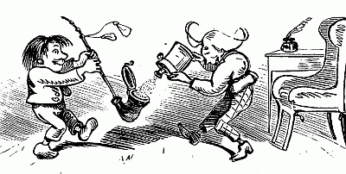
Richard Millington (Victoria, Wellington)
“Max Pulver’s Himmelpfortgasse: Cocaine in Interwar Vienna.”

Swiss writer Max Pulver (1889-1956) is best known for his contribution to graphology, but he entered this field only after a failed career as a literary writer. His 1927 novel Himmelpfortgasse takes its title from a street in central Vienna and describes an intellectual, tormented by the contradictions in his own personality, who uses cocaine to strip away the layers of social conditioning and confront himself with the essence of his own soul. Promoted by publisher Kurt Wolff as “the novel of the vice of our time,” its sensational presentation translated into neither commercial nor critical success, and Pulver soon distanced himself from his own book. This paper reconsiders the novel as a reflection of cocaine use in interwar Germany and Austria.

Marco Sonzogni (Victoria, Wellington)
“Cigars and Cigarettes in 1930s Italy: a Poetic Perspective.”

Interwar Italy saw a number of changes and initiatives aimed at widening the knowledge and use of tobacco – from various acts of legislation and the institution of the Tobacco State Monopoly, to design competitions, books, documentaries, and films. In this paper, however, I will look at tobacco from a different, poetic perspective. The poetry of Italian Nobel Laureate Eugenio Montale (1896-1981) is crowded with female figures – so much so that critics talk about a quaestio de mulieribus, a quest for women. What all of these women have in common is their daunting mission of saving the poet from his existential trials and tribulations. Irma Brandeis (1905-1990), an American academic and writer of Viennese Jewish descent, is unquestionably the most influential of them. Looking at biographical, archival and poetic evidence, and adopting the metaphor of smoking as looking glass, this paper follows “the last shreds of tobacco” (‘Nuove Stanze’, La bufera e altro) to re-trace the personal and poetic story of Eusebio and Clizia – both heavy and lifelong smokers – between Italy and the US in the 1930s. Montale’s favourite cigars – produced by the Fabbrica Tabacchi Brissago on the shores of Lake Maggiore in Northern Italy – were made with the best tobacco, Kentucky, imported from the region of Springfield, Tennessee, in the USA. A fitting analogy, as it were, for a relationship that generated some of finest poems of the twentieth century even though, or precisely because, it ended up in smoke.

Kerry Nitz (Victoria, Wellington)
“Alcohol in the Early Novellas of Hermann Stehr.”
Hermann Stehr’s first three novellas, Der Graveur (1898), Meicke, der Teufel (1898) and Der Schindelmacher (1899) are a source of evidence for attitudes towards alcohol in late 19th century working class Silesia. Most noticeable is a marked difference in the author’s treatment of drinking beer versus drinking schnapps, with connections drawn between drinking schnapps and the road to ruin. The female characters reflect this connection through a judgmental attitude which looks down on male characters’ drinking. This contrasts with the pressure to conform in the portrayal of a drinking society amongst male workers.

Chris Rudge (University of Sydney)
“LSD, mescaline & the experimental imaginary in European history.”

Leo Perutz’s novel Saint Peter’s Snow (1933) offers a fascinating representation of the ideas circulating in the 1930s about the possible chemical synthesisation of such “vegetable substances” as mescaline and psilocybin in Germany and central Europe. Promptly banned by the Nazi government upon its publication, Perutz’s text revolves around a “secret experiment to make a mind-altering drug from a white mildew occurring on wheat—a mildew called Saint Peter’s Snow.” By considering Perutz’s dystopic novel in combination with revisionist claims of Willis Harmann about the German origins of LSD and historical studies of state-run psychological experiments, my paper examines the literary and historical representations of the “psychotomimetics” in the period immediately before, during, and after their first appearance in Central Europe.

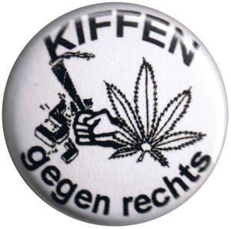

Participant Contact Information

Luc Arnault luc.arnault(at)vuw.ac.nz
Rob Imre robert.imre(at)newcastle.edu.au
Alexander Maxwell alexander.maxwell(at)vuw.ac.nz
Richard Millington richard.millington(at)vuw.ac.nz
Kerry Nitz kerry.nitz(at)vuw.ac.nz
Chris Rudge chris(at)rudge.tv
Marco Sonzogni marco.sonzogni(at)vuw.ac.nz

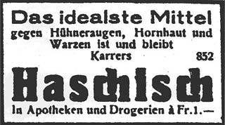

This event is free and open to the public.



