The Czechs and their Neighbours

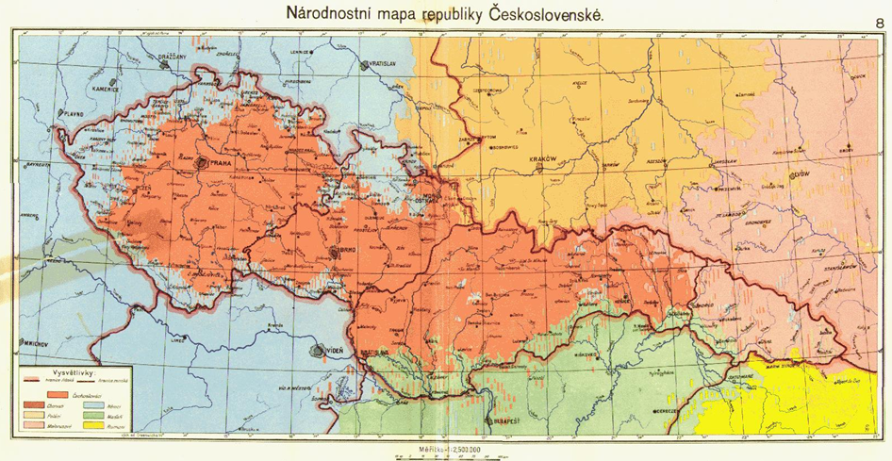

Victoria University of Wellington, 2 July 2013

The First Czechoslovak Republic, while heralded as a triumph of Wilsonian peacemaking after its founding, proved no more immune from nationalist tensions than its predecessor, the Austro-Hungarian monarchy. The state’s official census recognized sizeable Russian, Polish, German, Hungarian and Jewish populations; the majority “Czechoslovak” ethnicity additionally masked the particularist loyalties of Slovaks, Silesians, and arguably Moravians, Chodové, Roma, and so forth.

This workshop, which takes place immediately before the AAEH “Faultlines” conference in Wellington, considers the relationship between Czechs and their neighbours. Papers in the provisional schedule examine the Czech relationship to Germans, Lusatian-Sorbs, Rusyns, and Jews; we welcome papers that either supplement or duplicate this list. The New Zealand Slavonic Journal, a journal with a presence on J-stor, has already expressed interest in publishing selected papers in 2014.

Workshop Schedule (2 July 2013)

Session 1
12:30 – 1:45 Czechs and National Self-Determination

Matthew Vink
“Rudolf Lodgman von Auen
and German Bohemian National Self-Determination, 1918-1919.”

Alexander Maxwell
“Czechs and Sorbs at the Paris Peace Conference.”



Session 2
2:00 – 4:00 Nation and the “other” in Czech historical narratives

Geoffrey Brown
“The Czech Media and Subcarpathian Ruthenia
in the Interwar Period.”

Jan Láníček (University of New South Wales)
“Czechs and Jews during the Second World War:
Historiography and open Questions”

Anna Rosenbaum (University of Sydney)
“The Czechs and their Fellow Travellers:
The Question of Nationalism on their Big Brother’s playground.”
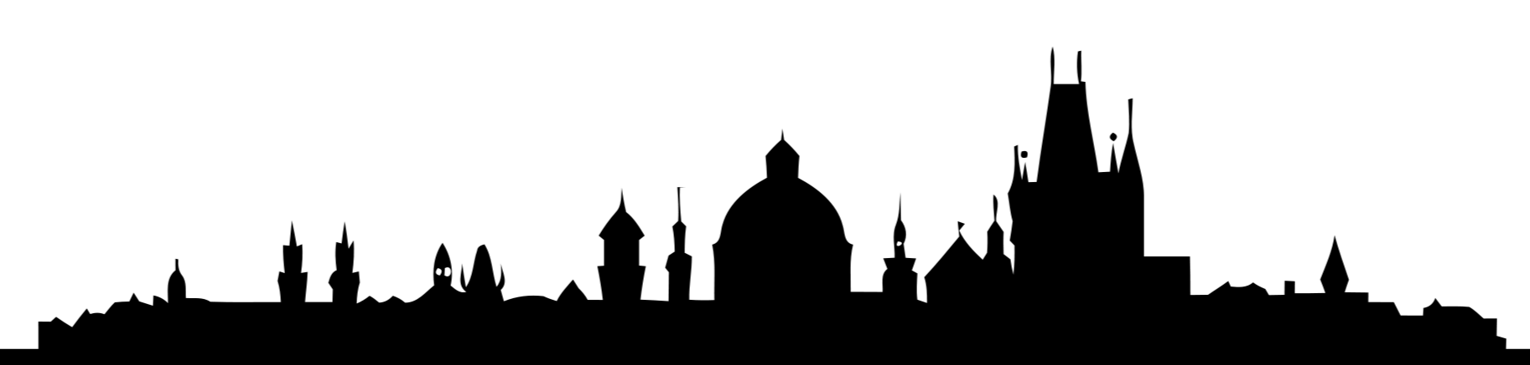

Workshop Dinner
7:00 Floriditas Restaurant
161 Cuba St Tel: (04) 381 2212
Abstracts

Geoffrey Brown
wildroo12@yahoo.com
“The Czech Media and Subcarpathian Ruthenia
in the Interwar Period.”

Czech journalists saw Ruthenia as an unknown land of mystery and exoticism, a terra incognita which encouraged comparisons to other territories which Czechs considered to be remote and primitive such as Bosnia and Herzegovina, Siberia, Africa, Asia and the Orient. Such comparisons in the media would eventually lead to expressions such as “The Czechoslovak Bosnia” entering the vocabulary of the Czech public mainstream. Comparing Subcarpathian Ruthenia with primitive foreign regions suggested Ruthenia was a colonized territory, an image which was further enhanced through depictions of the Rusyn people as uncivilized, savage and childlike. The media also presented the Czech nation as a guiding light among the Slavs, ready to lead the Rusyns to a brighter future in the new Czechoslovak state.

Jan Láníček (University of New South Wales)
j.lanicek@unsw.edu.au
“Czechs and Jews during the Second World War:
Historiography and open Questions”

Already during the Second World War, the Czechoslovak resistance movement was successful in creating the myth of the decent Czech attitude towards the Jews at the time of the Protectorate of Bohemia and Moravia. Also the prevailing trend in historiography suggests that decent Czech people rejected Nazi racial anti-Semitism and supported the persecuted Jewish minority. Yet available evidence suggests that the number of Jews who survived the war in the Protectorate in hiding is minimal, in fact much lower than in the neighbouring countries, including Germany or Poland. The paper analyses the factors that contributed to the very low survival rate for Jews in the Czech lands.

Alexander Maxwell
alexander.maxwell@vuw.ac.nz
“Czechs and Sorbs at the Paris Peace Conference.”

At the 1919 Paris Peace conference, diplomats sketching Central Europe’s new frontiers considered assigning Lusatia to the new Czechoslovak Republic. Lusatia lies in the far east of the contemporary Federal Republic of Germany, along the Polish border, and has since medieval times been divided into Upper Lusatia (in Saxony) and Lower Lusatia (in Brandenburg). No administrative unit called Lusatia exists today, though memories of the historic region linger. Schemes for a Czechoslovak Lusatia illustrate how historic claims and great power politics clashed with the idealistic national rhetoric American President Woodrow Wilson brought to European peacemaking.

Anna Rosenbaum (University of Sydney)
mrosenbauma@gmail.com
“The Czechs and their Fellow Travelers:
The Question of Nationalism on their Big Brother’s playground.”

This paper will examine whether there were any common issues in the past between the Czechs and their neighbours. Moreover, it will focus on changes in relations between the Czechs and their neighbours following the Second World War until the fall of Communism in 1989. What were the forces that united them and was it possible to bury old enmities in post Communist Central Europe?

Matthew Vink
matthew.vink@vuw.ac.nz
“Rudolf Lodgman von Auen
and German Bohemian National Self-Determination, 1918-1919.”

Despite the establishment of a Czechoslovak state, German Bohemians remained confident they could achieve alternative arrangements for their own territory. Germans in the Czech lands subsequently established four semi-autonomous provinces, of which Provinz Deutschböhmen [Province of German Bohemia], led by its Governor, Rudolf Lodgman von Auen, represented the largest and most important province. Negotiations between the Deutschböhmische Landesversammlung [German Bohemian National Assembly] and the Národní výbor československý [Czechoslovak National Committee] eventually broke down, leading to the Czechoslovak military occupation of German Bohemia. German Bohemian leaders loudly opposed the actions of the Czechoslovak government and continued to proclaim their right to national self-determination, appealing to the Paris Peace Conference in order to have this right recognised. The denial of German Bohemian independence shows the limits of Wilsonian national self-determination at the Paris Peace Conference.



