Ukraine, Crimea, and the Crimean Tatars (1944-2014)

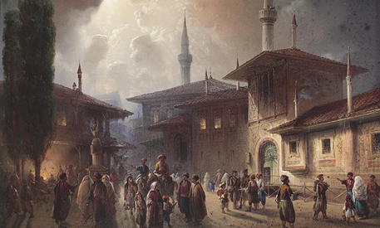
Tamilla Dauletbayeva
Central European University (Budapest)

On 27 June 2014, Petro Poroshenko, newly elected President of Ukraine, visiting Brussels, told CNN’s Chief International Correspondent Christian Amanpour that Ukraine would never see Crimea as a part of Russia, nor acknowledge its annexation, nor cease attempts to regain it. As he talked about the humanitarian crisis in Crimea, he referred to a small ethnic group of 248,200 Crimean Tatars, who have been living on the shores of Black Sea since the 15th century. How did the legacy of Stalinist policies unfold in the Crimea once the Crimean Tatars were allowed back home, and how has this legacy persisted after the collapse of the Soviet Union?

August 28 at 4:00 PM in the Wood Room (OK 406)

