Daniel S. Zbytek
Former Polish diplomat in South Asia and the United States, lecturer in history and political science, and co-editor of the Warsaw monthly Res Humana.

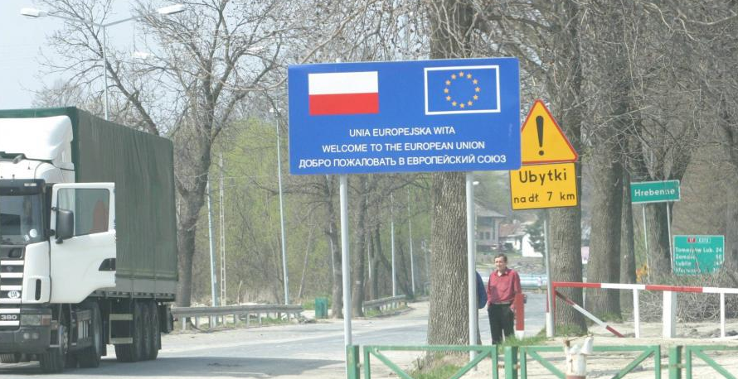

Poland and Ukraine:
Can they replace Russia in Eastern Europe again?

Until the 18th century, Poland and Ukraine formed one state, the Rzeczypospolita (Commonwealth), the biggest state in Europe. Today Ukraine is independent but at war with Russia. Turkey dreams again about the glory of its Ottoman past, and Germany is preoccupied with an uncontrolled inflow of migrants. Can Poland and Ukraine unite again to deliver peace to a turbulent Europe?

28 September 2016 / 5:00 pm / Wood Room (OK 406)
Victoria University, Wellington

This event is free and open to the public



