Nationalism as Classification
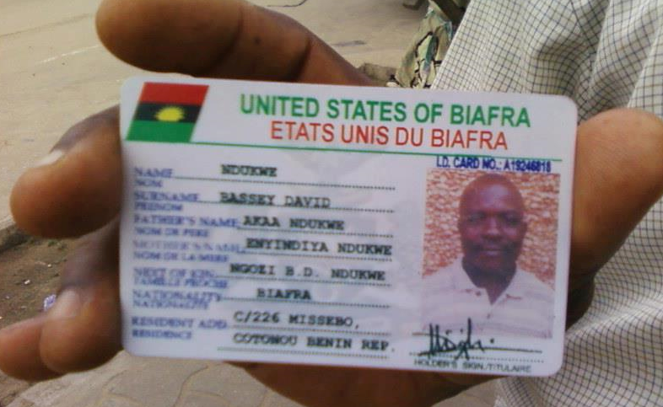

Nationalism theorist Rogers Brubaker proposed as an object of scholarly analysis “the modern state’s efforts to inscribe its subjects onto a classificatory grid: to identify and categorize people,” and generally drawing attention to historical actors who acquire “power to name, to identify, to categorize, to state what is what and who is who.” This conference explores classification and taxonomy as they affect nationality. Who classifies nations, how, and why? How are taxonomies imposed or resisted? How do national taxonomies interact with racial, linguistic, civilizational, or other taxonomies? We are interested both comparative analyses of nationalist taxonomies or case studies of individual taxonomizers.

A conference will take place on Thursday 7 July 2016 in the Wood Seminar Room (OK 406) at the Kelburn Campus of Victoria University in Wellington, New Zealand.
Conference Schedule

10:00 am Classification and Historiography
Rowan Lawrence (University of Sydney)
“National Identification: The nation as a classificatory and normative concept in Early Modern Britain”

Irena Vladimirsky (Achva Academic College, Israel)
“Nation and Nationalism as Encyclopedia definitions:
Russian and Soviet Encyclopedias (1880s-1930s).”

Alexander Maxwell (Victoria, Wellington)
“Effacing Panslavism: Linguistic Nationalism
and the Politics of Classification”

12:00 Lunch break

1:00 pm The Classifying State
Jasper Trautsch (University of Regensburg)
“American citizenship registration, British impressment, and war as a means to determine nationality in early 19th century America”

Zeev Levin (Hebrew University of Jerusalem)
“National Delimitation of Central Asia, 1924-1929:
Defining Tajiks and Bukharan Jews as National Minorities”

Jing Zhu (University of Edinburg)
“Classifying the ethnic minorities in southwest China by the most scientific and reliable criterion: body, in the first half of 20th century”

3:15 pm Classifying Intelligentsias
Eleanor Morecroft (Griffith University, Brisbane)
“Military History as National Taxonomizer: The Case of William Napier”

Sacha Davis (Newcastle, NSW)
“Hierarchies of Civilisation in Anglophone travel descriptions of Transylvania in the long nineteenth century”

Catherine Churchman (Victoria University)
“The History of the History of the Yue:
Ethnohistory and Classification in China”

Conference Abstracts

Catherine Churchman (Victoria University)
“The History of the History of the Yue:
Ethnohistory and Classification in South China”

Most research on the ethnic classification of the ancient Yue peoples of Southern China has concentrated on PRC scholarship of the last three decades but so far little research has been done into the ethnographic scholarship that preceded this. The identity of the Yue, their relationship to other ethnic groups mentioned in ancient texts, and what ultimately became of them have been subjects of Chinese writing for over three centuries. Through tracing the development of various different theories and classifications of the Yue from the mid-seventeenth century down to the mid twentieth-century I hope to show how these have reflected the political concerns of each generation of writers, and also how the pre-modern conceptions and investigations have informed modern scholarship and classifications both of the Yue and the various minzu of present-day South China.

Sacha Davis (Newcastle, NSW)
“Hierarchies of Civilisation in Anglophone travel descriptions of Transylvania in the long nineteenth century”

Anglophone travel writers visiting Transylvania in the long nineteenth century classified its inhabitants according to an East-West sliding scale of civilisation common to Western descriptions of East Europe. However, Transylvanians were not merely passive objects of such labelling. Rather, Anglophone interpretations reflected internal struggles between Hungarian, Romanian and Saxon nationalists in Transylvania, who asserted their own communities’ particular claims to cultural superiority and dismissed the claims of others. The point of entry of travel writers into the region, ethnically defined hospitality networks, and nationalist scholarship all swayed the views of Anglophone writers, transforming them into partisans in the region’s conflicts.

Zeev Levin (Hebrew University of Jerusalem)
“National Delimitation of Central Asia, 1924-1929:
Defining Tajiks and Bukharan Jews as National Minorities”

Over the last decades, scholars of Soviet nationalities policies have focused on majority populations or on the policy implementation. This paper examines Soviet policies toward two relatively close but separately defined national minority groups of Uzbekistan: the Tajiks and the Bukharan Jews. In 1924, when Soviet Republic of Uzbekistan was created, it consisted of many national minority groups. Tajiks and Bukharan Jews shared much in common. Their language, culture and living conditions were close. Nevertheless, in the second half of the 1920s, Soviet nationalities policy considered the two as different national groups. In the late 20s the Tajik administrative unit was ‘upgraded’ from autonomous republic status to the one of Soviet Republic, while the Jewish one was downgraded; its unique status was abolished in the late 30s.

Rowan Lawrence (University of Sydney)
“National Identification: The nation as a classificatory and normative concept in Early Modern Britain”

Individual belief that one meaningfully participates in a nation, rests in practice upon an understanding of the nation as one amongst many, which are often assumed to be in mutual competition. Early modern Britons metaphorically understood nations as individuals in a wider community, each concerned with status, reputation, health, virtue, strength, and greatness. Geography books compared nations’ physical, moral and behavioural properties, and domestic literature evaluated and classified members of the nation according to their contribution to its reputation and achievements. Post-enlightenment nationalisms conceal similar ideas behind ‘scientific’ lenses. Understanding the origins and development of national classification thus helps reconcile and understand various types of nationalism.
Alexander Maxwell (Victoria, Wellington)
“Effacing Panslavism: Linguistic Nationalism
and the Politics of Classification”

In the early nineteenth century, several Slavic intellectuals believed in a single Slavic nation speaking a single language, proposing various ideas about the nation’s “tribes” and the “dialects” of the Slavic language. Twentieth and twenty-first century scholars prove so extraordinarily unwilling to acknowledge the existence of Panslavism that several falsify evidence from the historical record. This paper discusses the thought of three sample Panslavs, Jan Kollár, Ljudevit Gaj, and Ľudovít Štúr, and documents their misrepresentation of their ideas.
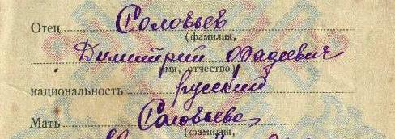

Eleanor Morecroft (Griffith University, Brisbane)
“Military History as National Taxonomizer:
The Case of William Napier”

William Napier’s History of the War in the Peninsula (pub.1828-1840) used the idea of the British Army as a mirror of the nation to comment on contemporary sociopolitical issues and push agendas of reform. Napier simultaneously glorified the British as a “warlike” people, contributing towards frameworks for the discussion of empire and imperial heroism later in the nineteenth century. As a military officer and public intellectual, Napier did not write as a direct representative of the state, but his cultural capital gave him the opportunity “to name, to identify, to categorise” the British and various Others. While acknowledging the influence he had as an individual, I place Napier not as a single-handed taxonomizer but as part of an ongoing conversation about war, nation, empire, and Britishness in which his voice emerged as one of the loudest and most powerful.

Jasper Trautsch (University of Regensburg)
“American citizenship registration, British impressment, and war as a means to determine nationality in early 19th century America”

An essential element of emerging nationalisms in Europe and North America was to structure the world into clearly demarcated nation-states and to classify humans as national citizens with distinct rights within and obligations to their respective nation-state. This paper analyses the inability of the American nation-state to clearly register its citizens, examines how the British practice of impressing citizens claiming to be Americans revealed the ambiguous nature of Americans’ nationality; and argues that the American government tried to compensate for its failure to establish a functioning citizenship registration and verification system and to assert its power to define and prove who was a member of the American nation by waging war against the former mother country, thereby forcing Great Britain to acknowledge the existence of an independent American nation-state and forcing people residing in the U.S. to reveal whether they were members of the American or British nation.

Irena Vladimirsky (Achva Academic Collegue, Israel)
“Nation and Nationalism as Encyclopedia definitions:
Russian and Soviet Encyclopedias (1880s-1930s).”

Encyclopedias gained popularity in Russia since the second half of the 19th century. The Russian Encyclopedic Dictionary was published by the professor I.N. Berezin in 1872-1879 and comprised of sixteen full volumes. Encyclopedia entries such as nationality and nationalism deserved certain attention, but were influenced by domestic and international policy of the Russian Empire. In the Encyclopedic Dictionary of Brockhaus-Efron, entries for Nation and nationality were influenced by Russian interests in the East. The Bolshevik revolution introduced a new vision of the national question, as expressed in the Big Soviet Encyclopedia in both the first and second edition (the so-called Stalin encyclopedia). The development of these entries definitions deserves a special analysis of editorial boards, their academic or political affiliation and views, and the relevant encyclopedia contributors.

Jing Zhu (University of Edinburg)
“Classifying the ethnic minorities in southwest China by the most scientific and reliable criterion: body, in the first half of 20th century

Starting with the revelation that in China’s long history, the figures of ethnic groups did not always remain as fifty-six, as what has been propagandized and accepted in contemporary China, and it even varied frequently in different historical epochs. Focusing on Republican period (1911-1949), this paper probes the criteria of ethnic classification in China, and uncovers that body was conceptualized as the most scientific and reliable taxonomy criterion for classifying the races in China. The idea of considering body as ethnic classification criterion, was promoted in particularly by the Chinese scholars trained in European and American Universities. This was an influence of western anthropometry in the late 19th and early 20th century. Departments of anthropometry in the Academia Sinica were established and the researchers went to the northeast, the west of Hunan, Guizhou, and Yunnan several times, measuring the bodies of non-Han in the 1930s and 1940s. This paper sheds light on the history of anthropometry in China, a field scarcely studied, and examines how anthropometry contributed to the ethnic classification in Republican China. It argues that few taxonomy results were generated and the classification by scientific criteria (body or language) were in fact not integrated into the classifications discussed by several Chinese public intellectuals, politicians, historians and ethnologists. By contrast, history and the politics of nation building played more significant roles in deciding how many ethnic groups China should have in the first half of 20th century.

Conference Participants – Contact Information

Sacha Davis sachaedavis (at) hotmail.com
Rowan Lawrence rowan.lawrence (at) gmail.com
Zeev Levin levinzv (at) gmail.com
Alexander Maxwell alexander.maxwell (at) vuw.ac.nz
Eleanor Morecroft e.morecroft (at) griffith.edu.au
Jasper Trautsch Jasper.Trautsch (at) geschichte.uni-regensburg.de
Jing Zhu s1220737 (at) sms.ed.ac.uk
Irena Vladimirsky irena (at) ACHVA.AC.IL
Zeev Levin levinzv (at) gmail.com

