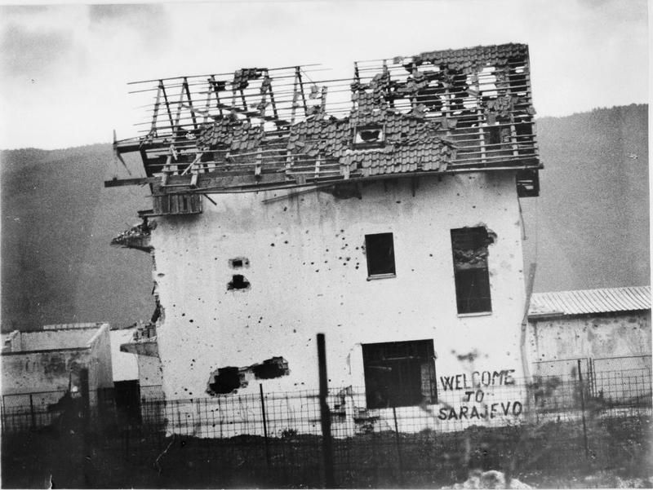
Bosnia: Looking back at a Tragedy
Major General (retd) Peter Williams

This talk is based on three operational tours in Bosnia and the former Yugoslavia. It examines the background to the Yugoslav conflict and describes how peace of a sort was imposed on the country. It ends by considering Bosnia’s future prospects in the New Europe.

5:00 pm / 4 April 2016 / Wood Room (OK 406)
Victoria University, Wellington

