Evolving Institutions in Ukraine:
A multi-disciplinary approach to post-Soviet space

Wednesday 11 May, 2016 Alan McDiarmond building, room 105

12:20 Welcome
Alexander Maxwell welcomes all

12:30 – 2:00 Ukrainian Institutions: Recent Developments

Iana Sabatovych (University of Canterbury, New Zealand)
“Is Ukrainian Crisis a Critical Juncture?
Analysing Current Change against Previous Paths”

Alexander Maxwell (Victoria University of Wellington, History)
“Russian and Ukrainian Claims to Crimea:
Historical, Ethnographic, Legal Aspects”

Ruth Fischer-Smith (University of Canterbury, Alumnus)
“Institutional Evolution and Development for
Ukrainian small and medium enterprises”

Coffee break

2:15 – 3:45 Ukraine and the European Union

James Headley (University of Otago)
“The Ukraine Crisis: A Clash between a Modern Russia
and a Postmodern European Union?”

Natalia Chaban (University of Canterbury, New Zealand)
“Between Attraction and Resentment:
Framing the EU in Ukrainian media”

Geoffrey Brown (Victoria University of Wellington, History)
“The Impact of Euromaidan
and the Donbass conflict in Zakarpattya Oblast”

Meal break

4:15 Final Discussion
Ruth Fischer-Smith, Chair
Abstracts

Geoffrey Brown (Victoria University of Wellington, History)
“The Impact of Euromaidan and the Donbass conflict in Zakarpattya Oblast”

In the aftermath of the 2014 Euromaidan uprising and the continuing conflict in Ukraine’s eastern Donbas region the western media has focused its attention on the conflict zone and the capital Kyiv. However, the crisis has had a significant impact on all regions of the country, politically, socially and economically. The Zakarpattia region in Ukraine’s south-west lies geographically furthest from the eastern conflict zone, yet in addition to economic and political turmoil it has faced heightened nationalist tensions among its ethnic minorities. Although the Slavic Rusyn minority have shown minimal interest in exploiting the crisis for irredentist means, the Kremlin-backed Russian media have sought to bolster Rusyn separatism as a means of undermining the Kyiv government. Unrest among Zakarpattia’s Hungarian minority has also increased after encouragement from outside Ukraine’s borders; Hungary's Jobbik party has called the Ukrainian crisis an opportunity to "finally resolve the situation of the Transcarpathian Hungarians". Members of the Hungarian minority have refused to enlist and fight for Ukrainian sovereignty against the Donbas separatists, some openly sympathising with the rebels’ wish to separate from Kyiv. This presentation will address the causes and consequences of regional upheaval in Zakarpattia oblast since the Euromaidan events in Kyiv in early 2014.
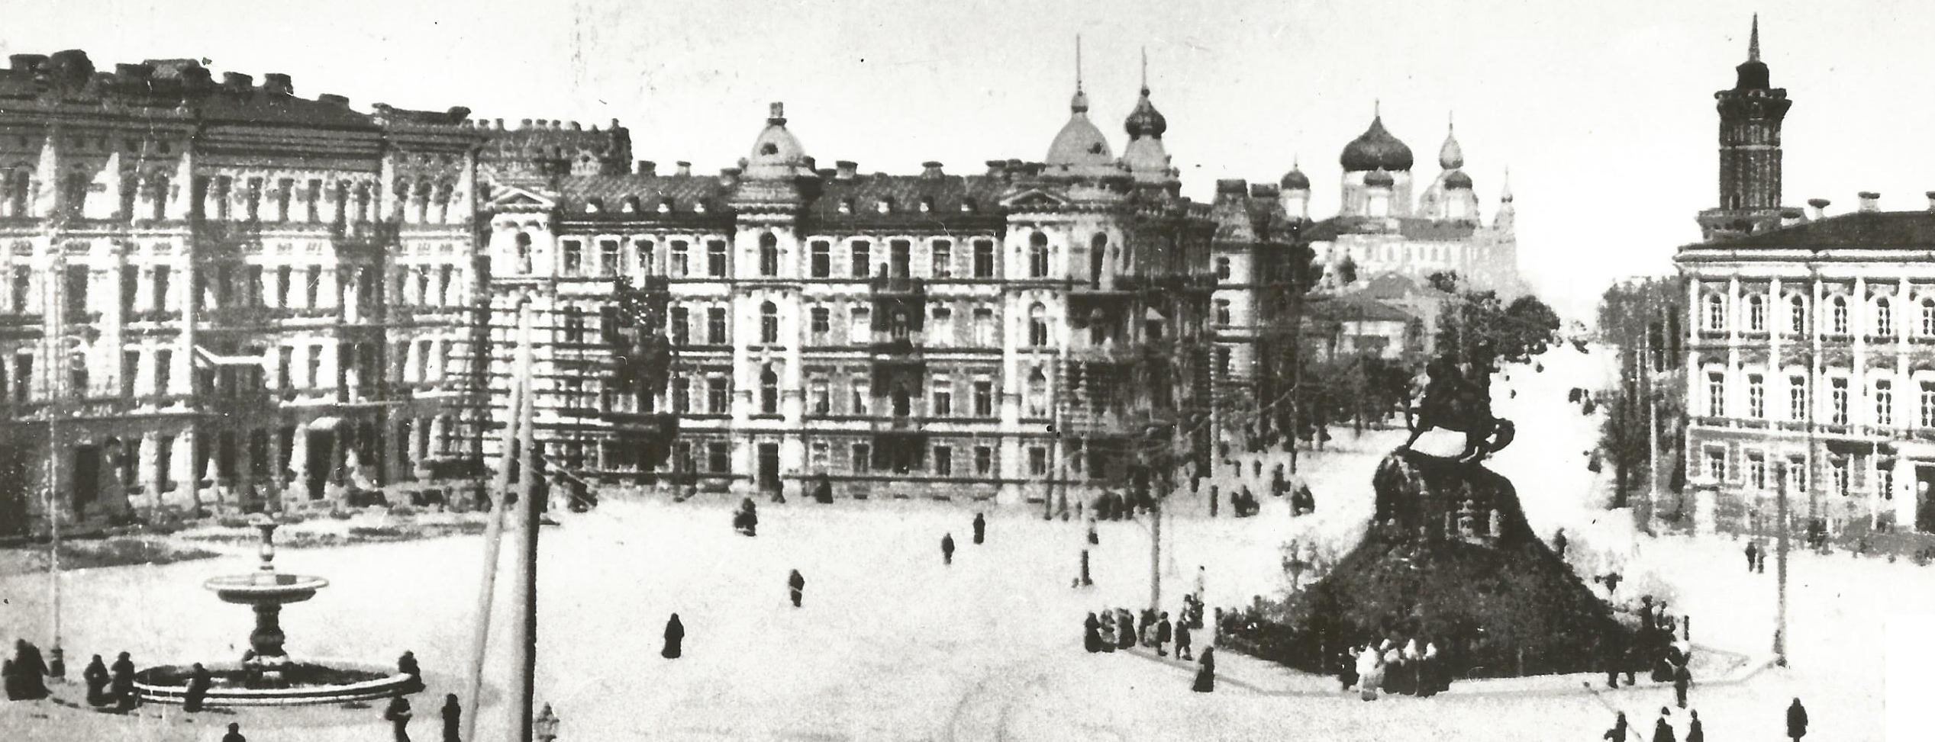

Natalia Chaban (University of Canterbury, New Zealand)
“Between Attraction and Resentment: Framing the EU in Ukrainian media”

This paper advances the ‘Normative Power Europe’ theoretical agenda by shifting analytical focus to norm-takers instead of norm-makers. How can particular visions about the EU as a foreign policy actor be disseminated in societies beyond the Union’s borders, and in its neighbours in particular? The concept of ‘cultural filters’ helps distinguish the range of receivers’ reactions from rejection and resistance to adaption and adoption. Media discourses shape images and perceptions of important international counterparts. Empirically, the paper frames the EU as a ‘normative’ actor in the Ukrainian press during the ongoing euro debt and migration crises, in the aftermaths of the terrorist attacks in Paris and Brussels, contending a critical need for Europe to diagnose and understand perceptions of the EU in this volatile strategic neighbour at times of global, regional and internal crises.

Ruth Fischer-Smith (University of Canterbury, Alumnus)
“Institutional evolution and development for Ukrainian small and medium enterprises”

Small and medium enterprises (SMEs) are a key ingredient for a healthy economy, and thus their SME policy settings are often handled by government development agencies. As organisations, such development agencies are subject to the kinds of institutional challenges that impact all organisations, including obstacles in policy design and implementation. As government administrations change, through elections and political events, policy settings for SMEs may change with them, resulting in institutional inconsistency that can detract significantly from potential policy impact. This article examines one such agency in Ukraine, the State Committee of Ukraine for Regulatory Policy and Entrepreneurship (SCURPE), assessing its role and evolution in supporting Ukraine’s developing SME sector. Using a combination of institutional analysis and policy implementation assessment, this article provides a critical overview of SCURPE’s role within a transitioning economy (Ukraine). A theoretical policy framework constructed around conditions specific to post-communist Europe, the Expanded Policy Implementation Criteria (EPIC), provides a more accurate analysis than have previous frameworks built around traditional pluralist democracies. This article also explores how a growing policy advocacy culture amongst SMEs is interacting with Ukraine’s traditionally vertical power structures to create new policy opportunities.
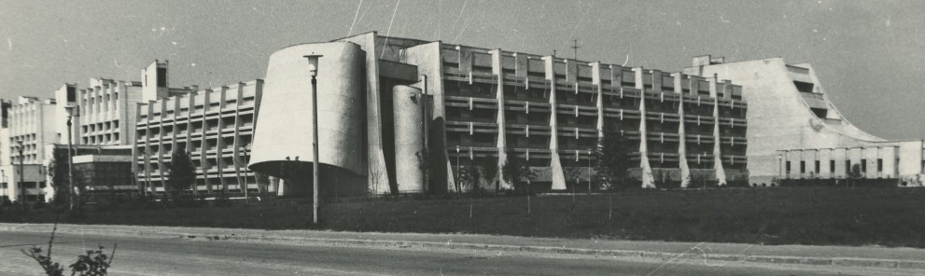

James Headley, University of Otago
“The Ukraine Crisis: A Clash between a Modern Russia
and a Postmodern European Union?”

A common interpretation of the Ukraine crisis, drawing on Robert Cooper, is of a clash between ‘postmodern’ European Union (EU) and ‘modern’ Russia: Russia sees the world through a ‘Westphalian’ lens of sovereign states and acts on the basis of raison d’état, whereas the EU promotes norms rather than interests and views the world through a post-Westphalian world in which sovereignty is pooled. Yet the Ukraine crisis shows that as integration within the EU deepens, the external borders and the relationship of external states to the EU become more significant, raising issues familiar from the ‘modern’ rise of the nation-state. The crisis in Ukraine concerns the political, economic and identity orientation of a state that emerged from the multinational Soviet Union; these issues have been a defining feature of the ‘modern’ world. Finally, the ‘postmodern EU’ concept provides a teleological frame for understanding the development of statehood in which ‘Europe’ represents the next stage of history. Such exceptionalism encourages EU policymakers to believe that their policy is inherently legitimate and hence to disregard the views and interests of other states, a tendency that contributed to the crisis.

Alexander Maxwell (Victoria University of Wellington, History)
“Russian and Ukrainian Claims to Crimea: Historical, Ethnographic, Legal Aspects”

In the wake of the 2013 Maidan protests, which overthrew the corrupt Yanukovich government, pro-Russian soldiers seized control of the Crimean peninsula. After a contested referendum, Russia annexed the territory on 18 March 2014. This paper examines ethnographic, historical and legal aspects of the Crimean crisis. The Third Universal of 1917, the history of Ukraine’s frontiers in the Soviet Era, and the history of Ukrainian irredentism give at best mixed support for a Ukrainian Crimea. Data from the Ukrainian independence referendum of 1991 and the 2001 Ukrainian census support the legitimacy of Ukrainian sovereignty, but also the singularity of Crimean distinctiveness. The legal that while both Russia and Ukraine have grounds for claiming the peninsula, the 16 March 2014 referendum holds no legitimacy.

Iana Sabatovych (University of Canterbury, New Zealand)
“Is Ukrainian Crisis a Critical Juncture?
Analysing Current Change against Previous Paths”

Debates about the crisis in Ukraine have dealt with its implications with respect to Ukraine’s historical background and identity, and also the revival of geopolitics Ukraine’s role in the international arena, but assume that the crisis as a turning point for Ukraine’s further development. Applying a path-dependence approach can determine whether the Ukrainian crisis has in fact become such a turning point. A uniform framework of path-dependence draws on stateness, identity, foreign policy, political and economic system, political culture and character. It also compares the current crisis with previous critical junctures in Ukrainian history. Ukraine’s strong reorientation in foreign policy and social perceptions reflect an unachieved national consensus and democratic consolidation. Therefore, the Ukrainian crisis did not result in a paradigm shift and cannot be considered as a critical juncture.

This event was organized by
The Antipodean East European Study Group (Victoria University)
and the
National Centre for Resarch on Europe (Canterbury Univeristy),
part of the
New Zealand European Studies Network





