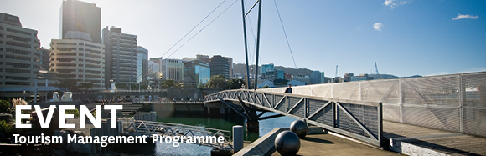
TOURISM MANAGEMENT, part of the School of Management, Victoria Business School, invites you to attend:
Book Launches: Advances in Tourism Research

Monday 8th December

12.00 - 1.30pm

Level 12, Boardroom/Dining Room,

Rutherford House, 23 Lambton Quay, Wellington

As part of Routledge's Advances in Tourism and Events Research, three new books have been published by Victoria University's tourism management group including;
The Future of Events and Festivals
Ian Yeoman, Martin Robertson, Karen Smith, Una McMahon-Beattie and Elisa Backer
Event Volunteering
Karen Smith, Leonie Lockstone-Binney, Kirsten Holmes and Tom Baum
The Tourism Education Futures Initiative
Darko Prebezac, Christian Schott and Pauline Sheldon

Sarah Meikle, Festival director of 'Wellington on a Plate', will facilitate a discussion on the authors' research, ideas and findings.

RSVP for catering purposes by 12 noon Thursday 4th December to tourism@vuw.ac.nz

