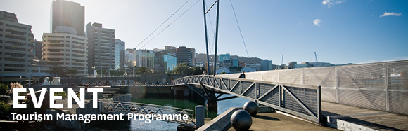
The Tourism Management Group, part of the School of Management, Victoria Business School,
invites you to attend the following seminar:
Walking on the Light Side:
Ventures into the mysterious world of ghost tourism
Presenter: Dr Jayne Krisjanous
Senior Lecturer in the School of Marketing and International Business
Victoria University of Wellington

Wednesday 15th March

12.45 – 1.45pm

Boardroom, Level 12, Rutherford House
Pipitea Campus, Wellington

Ghost tourism plays a significant part in the nightlife of urban areas all over the world. Although not conceived of as a mainstream tourist activity, and arguably comprised of experiences many tourists would prefer to avoid, it makes a valuable contribution to both cultural and tourism economies. Today ghost tourism is not just the domain of entrepreneurs with a penchant for the dramatic but also is beginning to be embraced by large established tourism enterprises, such as hotels and national heritage organisations.
In this seminar Jayne Krisjanous will present some of her research on ghost tourism that includes website analysis, interviews with ghost tour operators, and active participant observation in several countries. The role of ghost tourism within the broader spectrum of dark tourism will also be discussed.
Author
Dr Jayne Krisjanous is a Senior Lecturer in the School of Marketing and International Business at Victoria University of Wellington and is the school’s postgraduate programme director.
Her areas of research include healthcare marketing, historical research in marketing, consumer lifestyles, social marketing and dark tourism.

ALL WELCOME

Any queries please Email: tourism@vuw.ac.nz

